**THỰC HÀNH BUỔI 3 (Máy 17)**

Nguyễn Dương Quốc Huy

1150070017

**LAB 6**

**LUYỆN TẬP: Xây dựng chương trình đổi tiền tệ**

**Khai báo manifest:**

<manifest xmlns:android="http://schemas.android.com/apk/res/android"  
 package="com.example.nguyenduongquochuylab">  
  
 <application  
 android:allowBackup="true"  
 android:icon="@mipmap/ic_launcher"  
 android:label="@string/app_name"  
 android:roundIcon="@mipmap/ic_launcher_round"  
 android:supportsRtl="true"  
 android:theme="@style/Theme.AppCompat.Light.DarkActionBar">  
  
 <activity  
 android:name=".MainActivity"  
 android:exported="true">  
 <intent-filter>  
 <action android:name="android.intent.action.MAIN" />  
 <category android:name="android.intent.category.LAUNCHER" />  
 </intent-filter>  
 </activity>  
  
 </application>  
  
</manifest>

**Sau đó làm MainActivity:**

package com.example.nguyenduongquochuylab;  
  
import android.os.Bundle;  
import android.text.Editable;  
import android.text.TextWatcher;  
import android.view.LayoutInflater;  
import android.view.View;  
import android.view.ViewGroup;  
import android.widget.AdapterView;  
import android.widget.ArrayAdapter;  
import android.widget.BaseAdapter;  
import android.widget.EditText;  
import android.widget.ImageView;  
import android.widget.ListView;  
import android.widget.Spinner;  
import android.widget.TextView;  
  
import androidx.appcompat.app.AppCompatActivity;  
  
import java.text.DecimalFormat;  
  
public class MainActivity extends AppCompatActivity {  
  
 private EditText edtAmount;  
 private Spinner spFromCurrency;  
 private ListView lvResult;  
  
 private String[] currencyNames;  
 private String[] currencyUnits;  
 private int[] currencyFlags;  
  
 private double[][] rates;  
 private double[] results;  
  
 private int fromIndex = 0;  
 private CurrencyAdapter adapter;  
 private DecimalFormat df = new DecimalFormat("0.#####");  
  
 @Override  
 protected void onCreate(Bundle savedInstanceState) {  
 super.onCreate(savedInstanceState);  
 setContentView(R.layout.*activity_main*);  
  
 edtAmount = findViewById(R.id.*edtAmount*);  
 spFromCurrency = findViewById(R.id.*spFromCurrency*);  
 lvResult = findViewById(R.id.*lvResult*);  
  
 initData();  
 setupSpinner();  
 setupListView();  
 setupEvents();  
  
 edtAmount.setText("123");  
 updateResult();  
 }  
  
 private void initData() {  
 currencyNames = new String[]{  
 getString(R.string.*usd_name*),  
 getString(R.string.*eur_name*),  
 getString(R.string.*gbp_name*),  
 getString(R.string.*inr_name*),  
 getString(R.string.*aud_name*),  
 getString(R.string.*cad_name*),  
 getString(R.string.*zar_name*),  
 getString(R.string.*nzd_name*),  
 getString(R.string.*jpy_name*),  
 getString(R.string.*vnd_name*)  
 };  
  
 currencyUnits = new String[]{  
 getString(R.string.*usd_unit*),  
 getString(R.string.*eur_unit*),  
 getString(R.string.*gbp_unit*),  
 getString(R.string.*inr_unit*),  
 getString(R.string.*aud_unit*),  
 getString(R.string.*cad_unit*),  
 getString(R.string.*zar_unit*),  
 getString(R.string.*nzd_unit*),  
 getString(R.string.*jpy_unit*),  
 getString(R.string.*vnd_unit*)  
 };  
  
 currencyFlags = new int[]{  
 R.drawable.*flag_usd*,  
 R.drawable.*flag_eur*,  
 R.drawable.*flag_gbp*,  
 R.drawable.*flag_inr*,  
 R.drawable.*flag_aud*,  
 R.drawable.*flag_cad*,  
 R.drawable.*flag_zar*,  
 R.drawable.*flag_nzd*,  
 R.drawable.*flag_jpy*,  
 R.drawable.*flag_vnd* };  
  
 rates = new double[][]{  
 {1, 0.80518, 0.6407, 63.3318, 1.21828, 1.16236, 11.7129, 1.2931, 118.337, 21385.7},  
 {1.24172, 1, 0.79575, 78.6084, 1.51266, 1.44314, 14.5371, 1.60576, 146.927, 26561.8},  
 {1.56044, 1.25667, 1, 98.7848, 1.90091, 1.81355, 18.2683, 2.01791, 184.638, 33374.9},  
 {0.0158, 0.01272, 0.01012, 1, 0.01924, 0.01836, 0.18493, 0.02043, 1.8691, 337.811},  
 {0.82114, 0.66119, 0.5262, 52.086, 1, 0.95416, 9.61148, 1.06158, 97.112, 17567.9},  
 {0.86059, 0.69296, 0.55148, 54.5885, 1.04804, 1, 10.0732, 1.11258, 101.777, 18401.7},  
 {0.08541, 0.06877, 0.05473, 5.40852, 0.10398, 0.09924, 1, 0.11037, 10.0996, 1825.87},  
 {0.77402, 0.62319, 0.49597, 49.0031, 0.94215, 0.89951, 9.06754, 1, 91.5139, 16552.1},  
 {0.00846, 0.00681, 0.00542, 0.53547, 0.0103, 0.00983, 0.09908, 0.01093, 1, 180.837},  
 {0.00005, 0.00004, 0.00003, 0.00296, 0.00006, 0.00005, 0.00055, 0.00006, 0.00553, 1}  
 };  
  
 results = new double[currencyNames.length];  
 }  
  
 private void setupSpinner() {  
 ArrayAdapter<String> spAdapter =  
 new ArrayAdapter<>(this, android.R.layout.*simple_spinner_item*, currencyUnits);  
 spAdapter.setDropDownViewResource(android.R.layout.*simple_spinner_dropdown_item*);  
 spFromCurrency.setAdapter(spAdapter);  
 spFromCurrency.setSelection(6);  
 }  
  
 private void setupListView() {  
 adapter = new CurrencyAdapter();  
 lvResult.setAdapter(adapter);  
 }  
  
 private void setupEvents() {  
 spFromCurrency.setOnItemSelectedListener(new AdapterView.OnItemSelectedListener() {  
 @Override  
 public void onItemSelected(AdapterView<?> parent, View view, int position, long id) {  
 fromIndex = position;  
 updateResult();  
 }  
  
 @Override  
 public void onNothingSelected(AdapterView<?> parent) {  
 }  
 });  
  
 edtAmount.addTextChangedListener(new TextWatcher() {  
 @Override  
 public void beforeTextChanged(CharSequence s, int start, int count, int after) {  
 }  
  
 @Override  
 public void onTextChanged(CharSequence s, int start, int before, int count) {  
 }  
  
 @Override  
 public void afterTextChanged(Editable s) {  
 updateResult();  
 }  
 });  
 }  
  
 private void updateResult() {  
 String text = edtAmount.getText().toString().trim();  
 double amount = 0;  
 if (!text.isEmpty()) {  
 try {  
 amount = Double.*parseDouble*(text);  
 } catch (NumberFormatException ignored) {  
 }  
 }  
  
 for (int i = 0; i < results.length; i++) {  
 results[i] = amount * rates[i][fromIndex];  
 }  
  
 if (adapter != null) {  
 adapter.notifyDataSetChanged();  
 }  
 }  
  
 private class CurrencyAdapter extends BaseAdapter {  
  
 @Override  
 public int getCount() {  
 return currencyNames.length;  
 }  
  
 @Override  
 public Object getItem(int position) {  
 return currencyNames[position];  
 }  
  
 @Override  
 public long getItemId(int position) {  
 return position;  
 }  
  
 @Override  
 public View getView(int position, View convertView, ViewGroup parent) {  
 ViewHolder holder;  
 if (convertView == null) {  
 LayoutInflater inflater = LayoutInflater.*from*(MainActivity.this);  
 convertView = inflater.inflate(R.layout.*item_currency*, parent, false);  
 holder = new ViewHolder();  
 holder.imgFlag = convertView.findViewById(R.id.*imgFlag*);  
 holder.tvName = convertView.findViewById(R.id.*tvName*);  
 holder.tvValue = convertView.findViewById(R.id.*tvValue*);  
 convertView.setTag(holder);  
 } else {  
 holder = (ViewHolder) convertView.getTag();  
 }  
  
 holder.imgFlag.setImageResource(currencyFlags[position]);  
 holder.tvName.setText(currencyUnits[position] + " - " + currencyNames[position]);  
 holder.tvValue.setText(df.format(results[position]));  
  
 return convertView;  
 }  
  
 class ViewHolder {  
 ImageView imgFlag;  
 TextView tvName;  
 TextView tvValue;  
 }  
 }  
}

**Ở layout chúng ta làm giao diện:**

**Activity_main:**

<?xml version="1.0" encoding="utf-8"?>  
<LinearLayout xmlns:android="http://schemas.android.com/apk/res/android"  
 android:layout_width="match_parent"  
 android:layout_height="match_parent"  
 android:orientation="vertical"  
 android:fitsSystemWindows="true">  
  
 <LinearLayout  
 android:layout_width="match_parent"  
 android:layout_height="wrap_content"  
 android:orientation="horizontal"  
 android:padding="4dp"  
 android:layout_marginTop="4dp">  
  
 <EditText  
 android:id="@+id/edtAmount"  
 android:layout_width="0dp"  
 android:layout_height="wrap_content"  
 android:layout_weight="1"  
 android:inputType="numberDecimal"  
 android:hint="@string/textbox_hint" />  
  
 <Spinner  
 android:id="@+id/spFromCurrency"  
 android:layout_width="wrap_content"  
 android:layout_height="wrap_content"  
 android:layout_marginStart="4dp" />  
 </LinearLayout>  
  
 <View  
 android:layout_width="match_parent"  
 android:layout_height="1dp"  
 android:background="#CCCCCC" />  
  
 <ListView  
 android:id="@+id/lvResult"  
 android:layout_width="match_parent"  
 android:layout_height="0dp"  
 android:layout_weight="1"  
 android:divider="@android:color/darker_gray"  
 android:dividerHeight="1dp" />  
  
</LinearLayout>

**item_currency:**

<?xml version="1.0" encoding="utf-8"?>  
<LinearLayout xmlns:android="http://schemas.android.com/apk/res/android"  
 android:layout_width="match_parent"  
 android:layout_height="wrap_content"  
 android:orientation="horizontal"  
 android:padding="8dp">  
  
 <ImageView  
 android:id="@+id/imgFlag"  
 android:layout_width="40dp"  
 android:layout_height="24dp"  
 android:layout_gravity="center_vertical"  
 android:scaleType="centerCrop"  
 android:src="@drawable/flag_usd" />  
  
 <TextView  
 android:id="@+id/tvName"  
 android:layout_width="0dp"  
 android:layout_height="wrap_content"  
 android:layout_marginStart="8dp"  
 android:layout_weight="1"  
 android:text="USD"  
 android:textSize="16sp" />  
  
 <TextView  
 android:id="@+id/tvValue"  
 android:layout_width="wrap_content"  
 android:layout_height="wrap_content"  
 android:text="123.456"  
 android:textSize="14sp" />  
  
</LinearLayout>

**Ở Strings ta để các chuỗi:**

<resources>  
 <string name="app_name">Chương trình đổi tiền</string>  
 <string name="textbox_hint">Nhập số tiền</string>  
 <string name="usd_name">American Dollar</string>  
 <string name="eur_name">European Cash</string>  
 <string name="gbp_name">Greate Britain</string>  
 <string name="inr_name">Indian Rupe</string>  
 <string name="aud_name">Australia Dollar</string>  
 <string name="cad_name">Canadian Dollar</string>  
 <string name="zar_name">South Africa Rand</string>  
 <string name="nzd_name">New Zealand Dollar</string>  
 <string name="jpy_name">Yên Nhật</string>  
 <string name="vnd_name">Việt Nam Đồng</string>  
 <string name="usd_unit">USD</string>  
 <string name="eur_unit">EUR</string>  
 <string name="gbp_unit">GBP</string>  
 <string name="inr_unit">INR</string>  
 <string name="aud_unit">AUD</string>  
 <string name="cad_unit">CAD</string>  
 <string name="zar_unit">ZAR</string>  
 <string name="nzd_unit">NZD</string>  
 <string name="jpy_unit">JPY</string>  
 <string name="vnd_unit">VND</string>  
</resources>

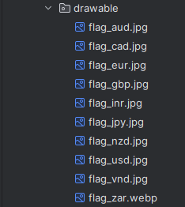**Trong drawable:**

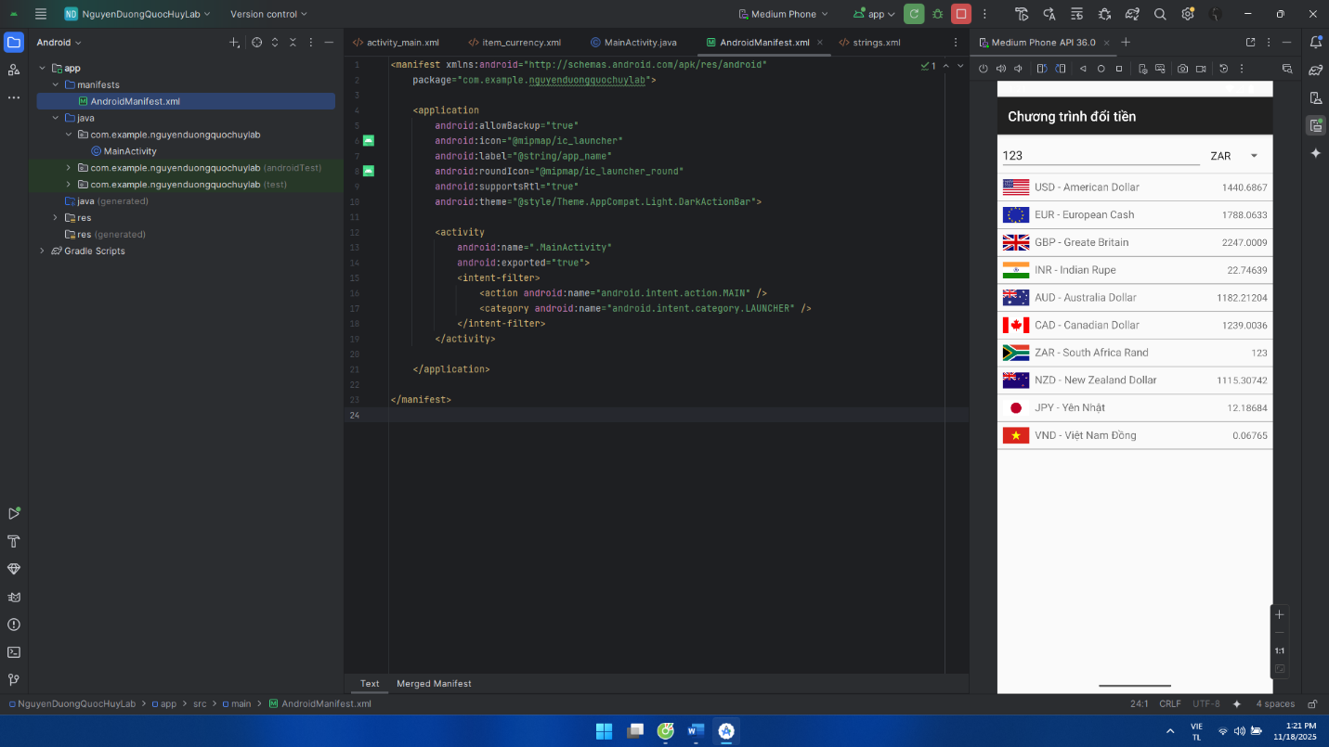**Giao diện:**

**BÀI TẬP: Xây dựng chương trình đổi đơn vị đo chiều dài**

**Khai báo trong manifest:**

<manifest xmlns:android="http://schemas.android.com/apk/res/android"  
 package="com.example.nguyenduongquochuylab">  
  
 <application  
 android:allowBackup="true"  
 android:icon="@mipmap/ic_launcher"  
 android:label="@string/app_name"  
 android:roundIcon="@mipmap/ic_launcher_round"  
 android:supportsRtl="true"  
 android:theme="@style/Theme.AppCompat.Light.DarkActionBar">  
 <activity  
 android:name=".MainActivity"  
 android:exported="true">  
 <intent-filter>  
 <action android:name="android.intent.action.MAIN" />  
 <category android:name="android.intent.category.LAUNCHER" />  
 </intent-filter>  
 </activity>  
 </application>  
  
</manifest>

**Code trong MainActivity:**

package com.example.nguyenduongquochuylab;  
  
import android.os.Bundle;  
import android.text.Editable;  
import android.text.TextWatcher;  
import android.view.LayoutInflater;  
import android.view.View;  
import android.view.ViewGroup;  
import android.widget.AdapterView;  
import android.widget.ArrayAdapter;  
import android.widget.BaseAdapter;  
import android.widget.EditText;  
import android.widget.ListView;  
import android.widget.Spinner;  
import android.widget.TextView;  
  
import androidx.appcompat.app.AppCompatActivity;  
  
import java.text.DecimalFormat;  
  
public class MainActivity extends AppCompatActivity {  
  
 private EditText edtLength;  
 private Spinner spFromUnit;  
 private ListView lvResult;  
  
 private String[] unitNames;  
 private String[] unitShort;  
  
 private double[][] rates;  
 private double[] results;  
  
 private int fromIndex = 0;  
 private LengthAdapter adapter;  
 private DecimalFormat df = new DecimalFormat("0.#####");  
  
 @Override  
 protected void onCreate(Bundle savedInstanceState) {  
 super.onCreate(savedInstanceState);  
 setContentView(R.layout.*activity_main*);  
  
 edtLength = findViewById(R.id.*edtLength*);  
 spFromUnit = findViewById(R.id.*spFromUnit*);  
 lvResult = findViewById(R.id.*lvResult*);  
  
 View header = getLayoutInflater().inflate(R.layout.*header_length*, lvResult, false);  
 lvResult.addHeaderView(header, null, false);  
  
 initData();  
 setupSpinner();  
 setupListView();  
 setupEvents();  
  
 edtLength.setText("1.23");   
 updateResult();  
 }  
  
 private void initData() {  
 unitNames = new String[]{  
 getString(R.string.*nm_name*),  
 getString(R.string.*mile_name*),  
 getString(R.string.*km_name*),  
 getString(R.string.*li_name*),  
 getString(R.string.*m_name*),  
 getString(R.string.*yard_name*),  
 getString(R.string.*foot_name*),  
 getString(R.string.*inch_name*)  
 };  
  
 unitShort = new String[]{  
 getString(R.string.*nm_unit*),  
 getString(R.string.*mile_unit*),  
 getString(R.string.*km_unit*),  
 getString(R.string.*li_unit*),  
 getString(R.string.*m_unit*),  
 getString(R.string.*yard_unit*),  
 getString(R.string.*foot_unit*),  
 getString(R.string.*inch_unit*)  
 };  
  
 rates = new double[][]{  
 {1.00000000, 0.86897624, 0.53995680, 0.04937365, 0.00053996, 0.00049374, 0.00016458, 0.00001371},  
 {1.15077945, 1.00000000, 0.62137130, 0.05681818, 0.00062137, 0.00056818, 0.00018939, 0.00001578},  
 {1.85200000, 1.60934400, 1.00000000, 0.09144000, 0.00100000, 0.00091440, 0.00030480, 0.00002540},  
 {20.2537183, 17.6000000, 10.9361330, 1.00000000, 0.01093613, 0.01000000, 0.00333333, 0.00027778},  
 {1852.00000, 1609.34400, 1000.00000, 91.4400000, 1.00000000, 0.91440000, 0.30480000, 0.02540000},  
 {2025.37183, 1760.00000, 1093.61330, 100.000000, 1.09361330, 1.00000000, 0.33333333, 0.02777778},  
 {6076.11549, 5280.00000, 3280.83990, 300.000000, 3.28083990, 3.00000000, 1.00000000, 0.08333333},  
 {72913.38583, 63360.00000, 39370.07870, 3600.00000, 39.37007870, 36.00000000, 12.00000000, 1.00000000}  
 };  
  
 results = new double[unitNames.length];  
 }  
  
 private void setupSpinner() {  
 ArrayAdapter<String> spAdapter =  
 new ArrayAdapter<>(this, android.R.layout.*simple_spinner_item*, unitShort);  
 spAdapter.setDropDownViewResource(android.R.layout.*simple_spinner_dropdown_item*);  
 spFromUnit.setAdapter(spAdapter);  
 spFromUnit.setSelection(1);   
 }  
  
 private void setupListView() {  
 adapter = new LengthAdapter();  
 lvResult.setAdapter(adapter);  
 }  
  
 private void setupEvents() {  
 spFromUnit.setOnItemSelectedListener(new AdapterView.OnItemSelectedListener() {  
 @Override  
 public void onItemSelected(AdapterView<?> parent, View view, int position, long id) {  
 fromIndex = position;  
 updateResult();  
 }  
  
 @Override  
 public void onNothingSelected(AdapterView<?> parent) { }  
 });  
  
 edtLength.addTextChangedListener(new TextWatcher() {  
 @Override  
 public void beforeTextChanged(CharSequence s, int start, int count, int after) { }  
  
 @Override  
 public void onTextChanged(CharSequence s, int start, int before, int count) { }  
  
 @Override  
 public void afterTextChanged(Editable s) {  
 updateResult();  
 }  
 });  
 }  
  
 private void updateResult() {  
 String text = edtLength.getText().toString().trim();  
 double amount = 0;  
 if (!text.isEmpty()) {  
 try {  
 amount = Double.*parseDouble*(text);  
 } catch (NumberFormatException ignored) { }  
 }  
  
 for (int i = 0; i < results.length; i++) {  
 results[i] = amount * rates[i][fromIndex];  
 }  
  
 if (adapter != null) {  
 adapter.notifyDataSetChanged();  
 }  
 }  
  
 private class LengthAdapter extends BaseAdapter {  
  
 @Override  
 public int getCount() {  
 return unitNames.length;  
 }  
  
 @Override  
 public Object getItem(int position) {  
 return unitNames[position];  
 }  
  
 @Override  
 public long getItemId(int position) {  
 return position;  
 }  
  
 @Override  
 public View getView(int position, View convertView, ViewGroup parent) {  
 ViewHolder holder;  
 if (convertView == null) {  
 LayoutInflater inflater = LayoutInflater.*from*(MainActivity.this);  
 convertView = inflater.inflate(R.layout.*item_length*, parent, false);  
 holder = new ViewHolder();  
 holder.tvValue = convertView.findViewById(R.id.*tvValue*);  
 holder.tvUnitName = convertView.findViewById(R.id.*tvUnitName*);  
 convertView.setTag(holder);  
 } else {  
 holder = (ViewHolder) convertView.getTag();  
 }  
  
 holder.tvValue.setText(df.format(results[position]));  
 holder.tvUnitName.setText(unitNames[position]);  
  
 return convertView;  
 }  
  
 class ViewHolder {  
 TextView tvValue;  
 TextView tvUnitName;  
 }  
 }  
}

**Sau đó làm giao diện trong layout:**

**Activity_main:**

<?xml version="1.0" encoding="utf-8"?>  
<LinearLayout xmlns:android="http://schemas.android.com/apk/res/android"  
 android:layout_width="match_parent"  
 android:layout_height="match_parent"  
 android:orientation="vertical"  
 android:fitsSystemWindows="true"  
 android:paddingTop="4dp">  
  
 <EditText  
 android:id="@+id/edtLength"  
 android:layout_width="match_parent"  
 android:layout_height="wrap_content"  
 android:inputType="numberDecimal"  
 android:hint="@string/textbox_hint" />  
  
 <Spinner  
 android:id="@+id/spFromUnit"  
 android:layout_width="match_parent"  
 android:layout_height="wrap_content" />  
  
 <ListView  
 android:id="@+id/lvResult"  
 android:layout_width="match_parent"  
 android:layout_height="0dp"  
 android:layout_weight="1"  
 android:divider="@android:color/darker_gray"  
 android:dividerHeight="1dp" />  
  
</LinearLayout>

**header_length:**

<?xml version="1.0" encoding="utf-8"?>  
<LinearLayout xmlns:android="http://schemas.android.com/apk/res/android"  
 android:layout_width="match_parent"  
 android:layout_height="wrap_content"  
 android:background="#009688"  
 android:padding="8dp">  
  
 <TextView  
 android:id="@+id/tvHeader"  
 android:layout_width="wrap_content"  
 android:layout_height="wrap_content"  
 android:text="@string/header_equiv"  
 android:textStyle="bold"  
 android:textColor="#FFFF00" />  
</LinearLayout>

**item_length:**

<?xml version="1.0" encoding="utf-8"?>  
<LinearLayout xmlns:android="http://schemas.android.com/apk/res/android"  
 android:layout_width="match_parent"  
 android:layout_height="wrap_content"  
 android:orientation="horizontal"  
 android:padding="8dp">  
  
 <TextView  
 android:id="@+id/tvValue"  
 android:layout_width="0dp"  
 android:layout_height="wrap_content"  
 android:layout_weight="1"  
 android:text="1.0688"  
 android:textSize="16sp" />  
  
 <TextView  
 android:id="@+id/tvUnitName"  
 android:layout_width="wrap_content"  
 android:layout_height="wrap_content"  
 android:text="Hải lý"  
 android:textSize="16sp" />  
  
</LinearLayout>

**Thiết lập strings:**

<resources>  
 <string name="app_name">Đổi đơn vị đo chiều dài</string>  
 <string name="textbox_hint">Nhập chiều dài</string>  
 <string name="nm_name">Hải lý</string>  
 <string name="mile_name">Dặm</string>  
 <string name="km_name">Kilometer</string>  
 <string name="li_name">Lý</string>  
 <string name="m_name">Met</string>  
 <string name="yard_name">Yard</string>  
 <string name="foot_name">Foot</string>  
 <string name="inch_name">Inches</string>  
 <string name="nm_unit">Hải lý</string>  
 <string name="mile_unit">Dặm</string>  
 <string name="km_unit">Km</string>  
 <string name="li_unit">Lý</string>  
 <string name="m_unit">Met</string>  
 <string name="yard_unit">Yard</string>  
 <string name="foot_unit">Foot</string>  
 <string name="inch_unit">Inch</string>  
 <string name="header_equiv">Tương đương với</string>  
</resources>

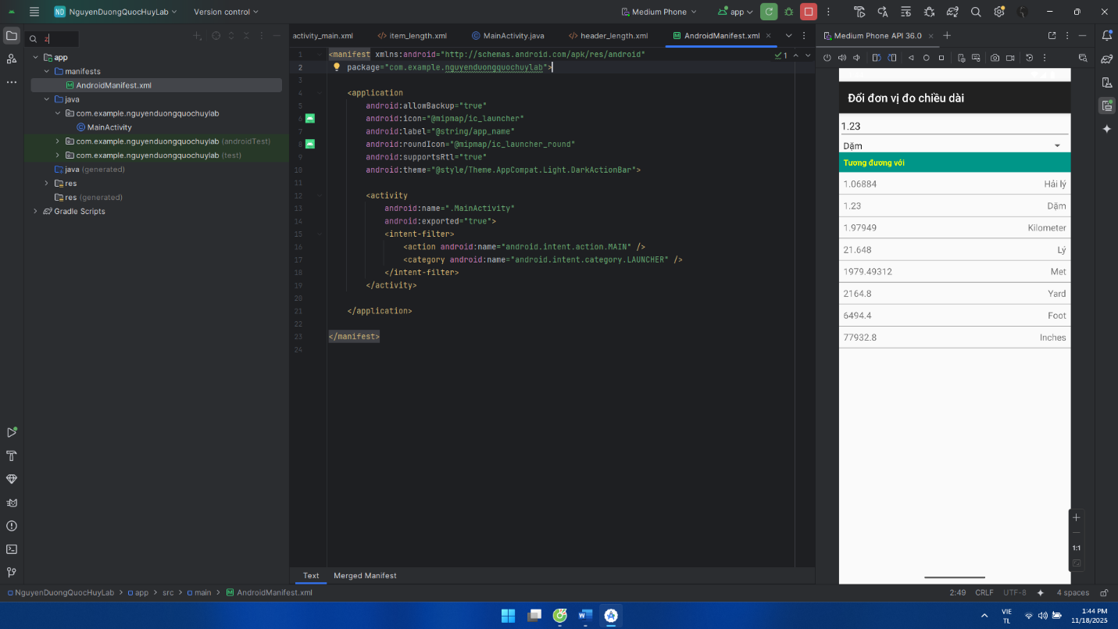**Giao diện:**

**LAB 7**

**BÀI TẬP 1: Sử dụng Custom Button, thiết kế giao diện như hình sau**

**Khai báo Manifest:**

<?xml version="1.0" encoding="utf-8"?>  
<manifest xmlns:android="http://schemas.android.com/apk/res/android"  
 package="com.example.nguyenduongquochuylab">  
  
 <application  
 android:allowBackup="true"  
 android:icon="@mipmap/ic_launcher"  
 android:label="DrawableExample"  
 android:roundIcon="@mipmap/ic_launcher_round"  
 android:supportsRtl="true"  
 android:theme="@style/Theme.AppCompat.Light.NoActionBar">  
 <activity  
 android:name=".MainActivity"  
 android:exported="true">  
 <intent-filter>  
 <action android:name="android.intent.action.MAIN" />  
 <category android:name="android.intent.category.LAUNCHER" />  
 </intent-filter>  
 </activity>  
 </application>  
  
</manifest>

**Gọi trong MainActivity:**

package com.example.nguyenduongquochuylab;  
  
import android.os.Bundle;  
import androidx.appcompat.app.AppCompatActivity;  
  
public class MainActivity extends AppCompatActivity {  
 @Override  
 protected void onCreate(Bundle savedInstanceState) {  
 super.onCreate(savedInstanceState);  
 setContentView(R.layout.*activity_main*);  
 }  
}

**Trong drawable:**

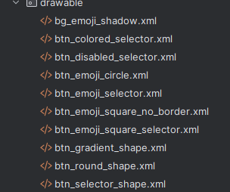

**Trong Layout:**

**Activity_main:**<?xml version="1.0" encoding="utf-8"?>  
<LinearLayout xmlns:android="http://schemas.android.com/apk/res/android"  
 android:orientation="vertical"  
 android:layout_width="match_parent"  
 android:layout_height="match_parent"  
 android:background="@android:color/white"  
 android:padding="16dp">  
  
 <TextView  
 android:id="@+id/tvTitle"  
 android:layout_width="match_parent"  
 android:layout_height="wrap_content"  
 android:text="Custom Button"  
 android:gravity="center"  
 android:textColor="#FF0000"  
 android:textStyle="bold"  
 android:textSize="22sp"  
 android:layout_marginTop="12dp"  
 android:layout_marginBottom="8dp" />  
  
 <LinearLayout  
 android:layout_width="match_parent"  
 android:layout_height="wrap_content"  
 android:orientation="horizontal"  
 android:layout_marginTop="8dp">  
  
 <TextView  
 android:layout_width="0dp"  
 android:layout_height="wrap_content"  
 android:layout_weight="1"  
 android:text="Selectors"  
 android:gravity="center"  
 android:textStyle="bold"  
 android:textColor="@android:color/black"  
 android:textSize="16sp" />  
  
 <TextView  
 android:layout_width="0dp"  
 android:layout_height="wrap_content"  
 android:layout_weight="1"  
 android:text="Shapes+Selectors"  
 android:gravity="center"  
 android:textStyle="bold"  
 android:textColor="@android:color/black"  
 android:textSize="16sp" />  
 </LinearLayout>  
  
 <LinearLayout  
 android:layout_width="match_parent"  
 android:layout_height="0dp"  
 android:layout_weight="1"  
 android:orientation="horizontal"  
 android:layout_marginTop="8dp">  
  
 <LinearLayout  
 android:layout_width="0dp"  
 android:layout_height="match_parent"  
 android:layout_weight="1"  
 android:orientation="vertical">  
  
 <Button  
 android:id="@+id/btnColoredSelector"  
 android:layout_width="match_parent"  
 android:layout_height="wrap_content"  
 android:text="COLORED SELECTOR"  
 android:textAllCaps="true"  
 android:textColor="@android:color/black"  
 android:background="@drawable/btn_colored_selector"  
 android:layout_marginTop="12dp" />  
  
 <Button  
 android:id="@+id/btnDisabledSelector"  
 android:layout_width="match_parent"  
 android:layout_height="wrap_content"  
 android:text="COLOR SELECTOR\nDISABLED"  
 android:textAllCaps="true"  
 android:textColor="#A07000"  
 android:gravity="center"  
 android:background="@drawable/btn_disabled_selector"  
 android:enabled="false"  
 android:layout_marginTop="12dp" />  
  
 <Button  
 android:id="@+id/btnEmojiLeftTop"  
 android:layout_width="wrap_content"  
 android:layout_height="wrap_content"  
 android:text="😊"  
 android:textSize="32sp"  
 android:layout_marginTop="24dp"  
 android:layout_gravity="center_horizontal"  
 android:background="@android:color/transparent"  
 android:stateListAnimator="@null"  
 android:elevation="0dp" />  
  
 <Button  
 android:id="@+id/btnEmojiLeftBottom"  
 android:layout_width="64dp"  
 android:layout_height="64dp"  
 android:text="😊"  
 android:textSize="26sp"  
 android:layout_marginTop="24dp"  
 android:layout_gravity="center_horizontal"  
 android:background="@drawable/btn_emoji_square_no_border"  
 android:stateListAnimator="@null"  
 android:elevation="0dp" />  
 </LinearLayout>  
  
 <LinearLayout  
 android:layout_width="0dp"  
 android:layout_height="match_parent"  
 android:layout_weight="1"  
 android:orientation="vertical"  
 android:layout_marginStart="8dp">  
  
 <Button  
 android:id="@+id/btnRoundShape"  
 android:layout_width="match_parent"  
 android:layout_height="wrap_content"  
 android:text="ROUND SHAPE"  
 android:textAllCaps="true"  
 android:textColor="@android:color/black"  
 android:background="@drawable/btn_round_shape"  
 android:layout_marginTop="12dp" />  
  
 <Button  
 android:id="@+id/btnGradientShape"  
 android:layout_width="match_parent"  
 android:layout_height="wrap_content"  
 android:text="SHAPE WITH GRADIENT"  
 android:textAllCaps="true"  
 android:textColor="@android:color/black"  
 android:background="@drawable/btn_gradient_shape"  
 android:layout_marginTop="12dp" />  
  
 <Button  
 android:id="@+id/btnSelectorShape"  
 android:layout_width="match_parent"  
 android:layout_height="wrap_content"  
 android:text="SELECTOR SHAPE"  
 android:textAllCaps="true"  
 android:textColor="@android:color/black"  
 android:background="@drawable/btn_selector_shape"  
 android:layout_marginTop="12dp" />  
  
 <Button  
 android:id="@+id/btnEmojiRight"  
 android:layout_width="64dp"  
 android:layout_height="64dp"  
 android:text="😊"  
 android:textSize="26sp"  
 android:layout_marginTop="24dp"  
 android:layout_gravity="center_horizontal"  
 android:background="@drawable/btn_emoji_square_selector"  
 android:stateListAnimator="@null"  
 android:elevation="0dp" />  
 </LinearLayout>  
 </LinearLayout>  
  
 <TextView  
 android:id="@+id/tvFooter"  
 android:layout_width="match_parent"  
 android:layout_height="wrap_content"  
 android:text="Made by Quoc Huy"  
 android:gravity="center"  
 android:textColor="#1E88E5"  
 android:textSize="12sp"  
 android:layout_marginBottom="8dp" />  
  
</LinearLayout>

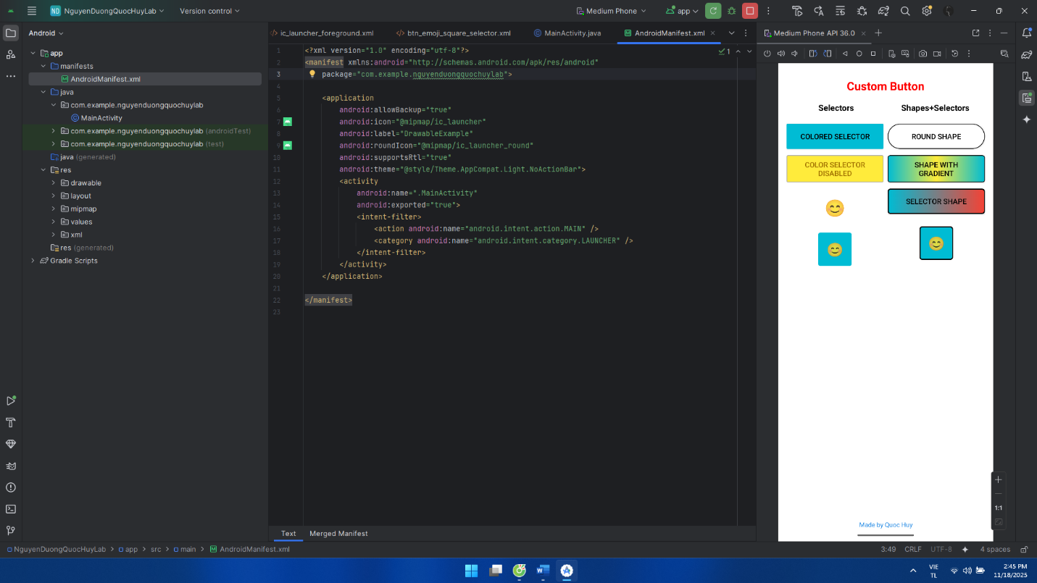**Giao diện:**

**BÀI TẬP 2: Sử dụng giao diện ở Bài tập 1, kết hợp thêm Custom Toast và Custom Dialog thiết kế**

**Cập nhật lại trong MainActivity:**package com.example.nguyenduongquochuylab;  
  
import android.os.Bundle;  
import android.view.Gravity;  
import android.view.LayoutInflater;  
import android.view.View;  
import android.view.ViewGroup;  
import android.widget.Button;  
import android.widget.EditText;  
import android.widget.Toast;  
  
import androidx.appcompat.app.AlertDialog;  
import androidx.appcompat.app.AppCompatActivity;  
  
public class MainActivity extends AppCompatActivity {  
  
 private Button btnToast, btnDialog;  
 private Button btnEmojiLeftTop, btnEmojiLeftBottom, btnEmojiRight;  
  
 @Override  
 protected void onCreate(Bundle savedInstanceState) {  
 super.onCreate(savedInstanceState);  
 setContentView(R.layout.*activity_main*);  
  
 btnToast = findViewById(R.id.*btnToast*);  
 btnDialog = findViewById(R.id.*btnDialog*);  
  
 btnEmojiLeftTop = findViewById(R.id.*btnEmojiLeftTop*);  
 btnEmojiLeftBottom = findViewById(R.id.*btnEmojiLeftBottom*);  
 btnEmojiRight = findViewById(R.id.*btnEmojiRight*);  
  
 btnToast.setOnClickListener(new View.OnClickListener() {  
 @Override  
 public void onClick(View v) {  
 showCustomToast();  
 }  
 });  
  
 btnDialog.setOnClickListener(new View.OnClickListener() {  
 @Override  
 public void onClick(View v) {  
 showCustomDialog();  
 }  
 });  
  
 setupEmojiToggle(btnEmojiLeftTop);  
 setupEmojiToggle(btnEmojiLeftBottom);  
 setupEmojiToggle(btnEmojiRight);  
 }  
  
 private void setupEmojiToggle(final Button btn) {  
  
 btn.setText("😊");  
 btn.setTag(false);  
  
 btn.setOnClickListener(new View.OnClickListener() {  
 @Override  
 public void onClick(View v) {  
 boolean isSunglasses = (Boolean) btn.getTag();  
 if (isSunglasses) {  
 btn.setText("😊");  
 } else {  
 btn.setText("😎");  
 }  
 btn.setTag(!isSunglasses);  
 }  
 });  
 }  
  
 private void showCustomToast() {  
 LayoutInflater inflater = getLayoutInflater();  
 View layout = inflater.inflate(  
 R.layout.*layout_custom_toast*,  
 (ViewGroup) findViewById(R.id.*toast_root*)  
 );  
  
 Toast toast = new Toast(getApplicationContext());  
 toast.setDuration(Toast.*LENGTH_LONG*);  
 toast.setView(layout);  
 toast.setGravity(Gravity.*BOTTOM* | Gravity.*CENTER_HORIZONTAL*, 0, 150);  
 toast.show();  
 }  
  
 private void showCustomDialog() {  
 AlertDialog.Builder builder = new AlertDialog.Builder(this);  
 LayoutInflater inflater = getLayoutInflater();  
 View dialogView = inflater.inflate(R.layout.*layout_custom_dialog*, null);  
 builder.setView(dialogView);  
 builder.setCancelable(false);  
  
 final AlertDialog dialog = builder.create();  
  
 EditText edtUsername = dialogView.findViewById(R.id.*edtUsername*);  
 EditText edtPassword = dialogView.findViewById(R.id.*edtPassword*);  
 Button btnDongY = dialogView.findViewById(R.id.*btnDongY*);  
 Button btnThoat = dialogView.findViewById(R.id.*btnThoat*);  
  
  
 btnDongY.setOnClickListener(new View.OnClickListener() {  
 @Override  
 public void onClick(View v) {  
 String user = edtUsername.getText().toString().trim();  
 String pass = edtPassword.getText().toString().trim();  
  
 if (user.equals("admin") && pass.equals("admin")) {  
 Toast.*makeText*(MainActivity.this,  
 "Đăng nhập thành công (admin/admin)", Toast.*LENGTH_SHORT*).show();  
 } else {  
 Toast.*makeText*(MainActivity.this,  
 "Sai tài khoản hoặc mật khẩu", Toast.*LENGTH_SHORT*).show();  
 }  
 dialog.dismiss();  
 }  
 });  
  
 btnThoat.setOnClickListener(new View.OnClickListener() {  
 @Override  
 public void onClick(View v) {  
 dialog.dismiss();  
 }  
 });  
  
 dialog.show();  
 }  
}

**Cập nhật thêm layout:**

**Activity_main:**

<?xml version="1.0" encoding="utf-8"?>  
<LinearLayout xmlns:android="http://schemas.android.com/apk/res/android"  
 android:orientation="vertical"  
 android:layout_width="match_parent"  
 android:layout_height="match_parent"  
 android:background="@android:color/white"  
 android:padding="16dp">  
  
 <TextView  
 android:id="@+id/tvTitle"  
 android:layout_width="match_parent"  
 android:layout_height="wrap_content"  
 android:text="Custom Button"  
 android:gravity="center"  
 android:textColor="#FF0000"  
 android:textStyle="bold"  
 android:textSize="22sp"  
 android:layout_marginTop="12dp"  
 android:layout_marginBottom="8dp" />  
  
 <LinearLayout  
 android:layout_width="match_parent"  
 android:layout_height="wrap_content"  
 android:orientation="horizontal"  
 android:layout_marginTop="8dp">  
  
 <TextView  
 android:layout_width="0dp"  
 android:layout_height="wrap_content"  
 android:layout_weight="1"  
 android:text="Selectors"  
 android:gravity="center"  
 android:textStyle="bold"  
 android:textColor="@android:color/black"  
 android:textSize="16sp" />  
  
 <TextView  
 android:layout_width="0dp"  
 android:layout_height="wrap_content"  
 android:layout_weight="1"  
 android:text="Shapes+Selectors"  
 android:gravity="center"  
 android:textStyle="bold"  
 android:textColor="@android:color/black"  
 android:textSize="16sp" />  
 </LinearLayout>  
  
 <LinearLayout  
 android:layout_width="match_parent"  
 android:layout_height="0dp"  
 android:layout_weight="1"  
 android:orientation="horizontal"  
 android:layout_marginTop="8dp">  
  
 <LinearLayout  
 android:layout_width="0dp"  
 android:layout_height="match_parent"  
 android:layout_weight="1"  
 android:orientation="vertical">  
  
 <Button  
 android:id="@+id/btnColoredSelector"  
 android:layout_width="match_parent"  
 android:layout_height="wrap_content"  
 android:text="COLORED SELECTOR"  
 android:textAllCaps="true"  
 android:textColor="@android:color/black"  
 android:background="@drawable/btn_colored_selector"  
 android:layout_marginTop="12dp" />  
  
 <Button  
 android:id="@+id/btnDisabledSelector"  
 android:layout_width="match_parent"  
 android:layout_height="wrap_content"  
 android:text="COLOR SELECTOR\nDISABLED"  
 android:textAllCaps="true"  
 android:textColor="#A07000"  
 android:gravity="center"  
 android:background="@drawable/btn_disabled_selector"  
 android:enabled="false"  
 android:layout_marginTop="12dp" />  
  
 <Button  
 android:id="@+id/btnEmojiLeftTop"  
 android:layout_width="wrap_content"  
 android:layout_height="wrap_content"  
 android:text="😊"  
 android:textSize="32sp"  
 android:layout_marginTop="24dp"  
 android:layout_gravity="center_horizontal"  
 android:background="@android:color/transparent"  
 android:stateListAnimator="@null"  
 android:elevation="0dp" />  
  
 <Button  
 android:id="@+id/btnEmojiLeftBottom"  
 android:layout_width="64dp"  
 android:layout_height="64dp"  
 android:text="😊"  
 android:textSize="26sp"  
 android:layout_marginTop="24dp"  
 android:layout_gravity="center_horizontal"  
 android:background="@drawable/btn_emoji_square_no_border"  
 android:stateListAnimator="@null"  
 android:elevation="0dp" />  
  
 </LinearLayout>  
  
 <LinearLayout  
 android:layout_width="0dp"  
 android:layout_height="match_parent"  
 android:layout_weight="1"  
 android:orientation="vertical"  
 android:layout_marginStart="8dp">  
  
 <Button  
 android:id="@+id/btnRoundShape"  
 android:layout_width="match_parent"  
 android:layout_height="wrap_content"  
 android:text="ROUND SHAPE"  
 android:textAllCaps="true"  
 android:textColor="@android:color/black"  
 android:background="@drawable/btn_round_shape"  
 android:layout_marginTop="12dp" />  
  
 <Button  
 android:id="@+id/btnGradientShape"  
 android:layout_width="match_parent"  
 android:layout_height="wrap_content"  
 android:text="SHAPE WITH GRADIENT"  
 android:textAllCaps="true"  
 android:textColor="@android:color/black"  
 android:background="@drawable/btn_gradient_shape"  
 android:layout_marginTop="12dp" />  
  
 <Button  
 android:id="@+id/btnSelectorShape"  
 android:layout_width="match_parent"  
 android:layout_height="wrap_content"  
 android:text="SELECTOR SHAPE"  
 android:textAllCaps="true"  
 android:textColor="@android:color/black"  
 android:background="@drawable/btn_selector_shape"  
 android:layout_marginTop="12dp" />  
  
 <Button  
 android:id="@+id/btnEmojiRight"  
 android:layout_width="64dp"  
 android:layout_height="64dp"  
 android:text="😊"  
 android:textSize="26sp"  
 android:layout_marginTop="24dp"  
 android:layout_gravity="center_horizontal"  
 android:background="@drawable/btn_emoji_square_selector"  
 android:stateListAnimator="@null"  
 android:elevation="0dp" />  
 </LinearLayout>  
 </LinearLayout>  
  
 <TextView  
 android:id="@+id/tvFooter"  
 android:layout_width="match_parent"  
 android:layout_height="wrap_content"  
 android:text="Made by Quoc Huy"  
 android:gravity="center"  
 android:textColor="#1E88E5"  
 android:textSize="12sp"  
 android:layout_marginBottom="8dp" />  
  
 <LinearLayout  
 android:layout_width="match_parent"  
 android:layout_height="wrap_content"  
 android:orientation="horizontal">  
  
 <Button  
 android:id="@+id/btnToast"  
 android:layout_width="0dp"  
 android:layout_height="48dp"  
 android:layout_weight="1"  
 android:text="TOAST"  
 android:textAllCaps="true"  
 android:textColor="@android:color/white"  
 android:background="@drawable/btn_bottom_round" />  
  
 <Button  
 android:id="@+id/btnDialog"  
 android:layout_width="0dp"  
 android:layout_height="48dp"  
 android:layout_weight="1"  
 android:text="DIALOG"  
 android:textAllCaps="true"  
 android:textColor="@android:color/white"  
 android:background="@drawable/btn_bottom_round"  
 android:layout_marginStart="8dp" />  
 </LinearLayout>  
  
</LinearLayout>

**layout_custom_dialog:**

<?xml version="1.0" encoding="utf-8"?>  
<LinearLayout xmlns:android="http://schemas.android.com/apk/res/android"  
 android:layout_width="wrap_content"  
 android:layout_height="wrap_content"  
 android:orientation="vertical"  
 android:padding="16dp"  
 android:background="@android:color/white">  
  
 <TextView  
 android:id="@+id/tvDialogTitle"  
 android:layout_width="match_parent"  
 android:layout_height="wrap_content"  
 android:text="Đăng nhập"  
 android:textStyle="bold"  
 android:textSize="18sp"  
 android:textColor="@android:color/black"  
 android:gravity="center" />  
  
 <TextView  
 android:layout_width="match_parent"  
 android:layout_height="wrap_content"  
 android:text="Tài khoản"  
 android:layout_marginTop="12dp"  
 android:textColor="@android:color/black" />  
  
 <EditText  
 android:id="@+id/edtUsername"  
 android:layout_width="250dp"  
 android:layout_height="wrap_content"  
 android:text="admin"  
 android:singleLine="true" />  
  
 <TextView  
 android:layout_width="match_parent"  
 android:layout_height="wrap_content"  
 android:text="Mật khẩu"  
 android:layout_marginTop="12dp"  
 android:textColor="@android:color/black" />  
  
 <EditText  
 android:id="@+id/edtPassword"  
 android:layout_width="250dp"  
 android:layout_height="wrap_content"  
 android:text="admin"  
 android:inputType="textPassword"  
 android:singleLine="true" />  
  
 <LinearLayout  
 android:layout_width="match_parent"  
 android:layout_height="wrap_content"  
 android:orientation="horizontal"  
 android:layout_marginTop="16dp"  
 android:gravity="end">  
  
 <Button  
 android:id="@+id/btnDongY"  
 android:layout_width="wrap_content"  
 android:layout_height="wrap_content"  
 android:text="ĐỒNG Ý" />  
  
 <Button  
 android:id="@+id/btnThoat"  
 android:layout_width="wrap_content"  
 android:layout_height="wrap_content"  
 android:text="THOÁT"  
 android:layout_marginStart="8dp" />  
 </LinearLayout>  
  
</LinearLayout>

**layout_custom_toast:**

<?xml version="1.0" encoding="utf-8"?>  
<LinearLayout xmlns:android="http://schemas.android.com/apk/res/android"  
 android:id="@+id/toast_root"  
 android:layout_width="wrap_content"  
 android:layout_height="wrap_content"  
 android:background="@drawable/bg_custom_toast"  
 android:orientation="horizontal"  
 android:padding="12dp">  
  
 <TextView  
 android:id="@+id/tvToast"  
 android:layout_width="wrap_content"  
 android:layout_height="wrap_content"  
 android:text="Custom Toast, made by QuocHuy"  
 android:textColor="@android:color/white"  
 android:textSize="14sp" />  
</LinearLayout>

**Giao diện:**

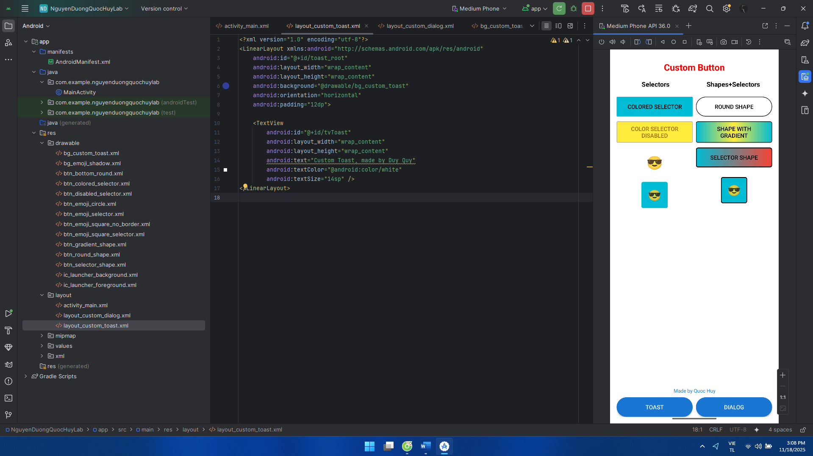

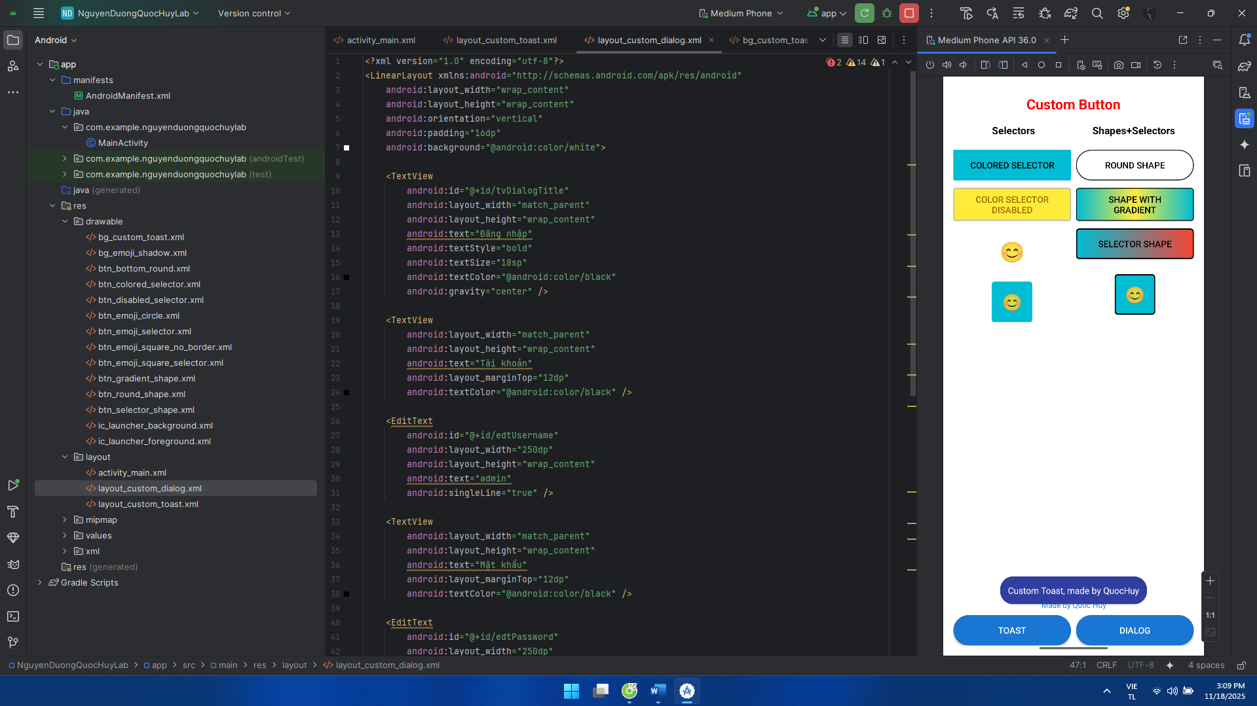

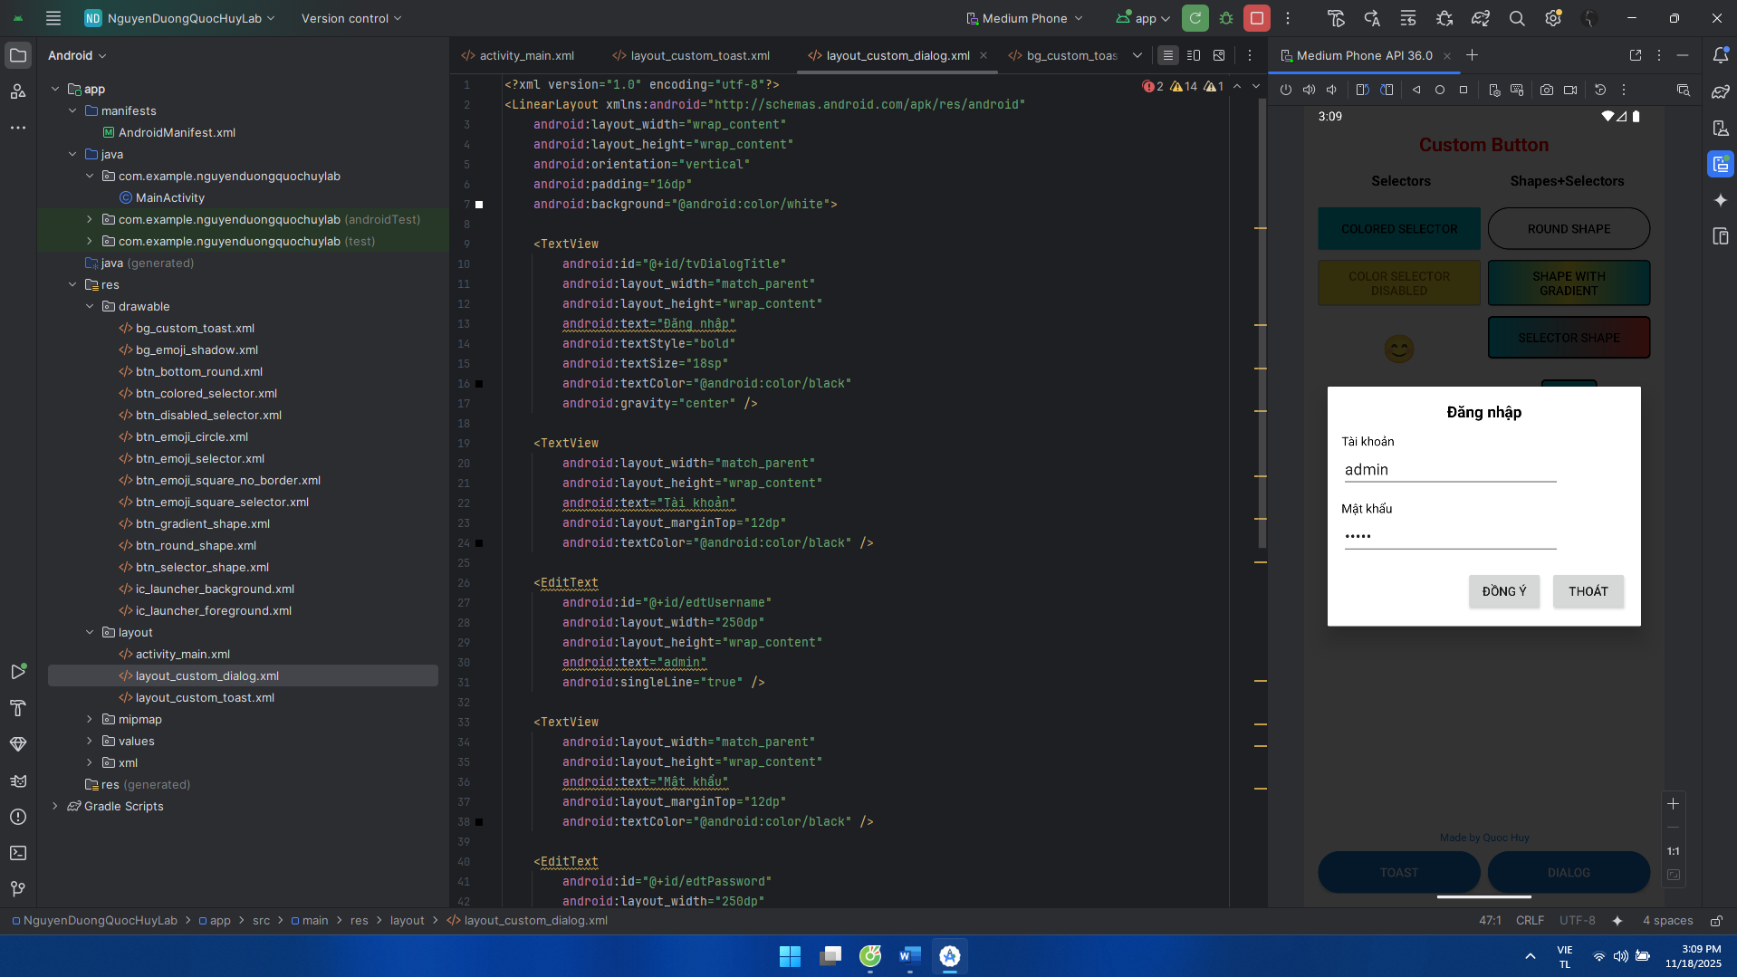

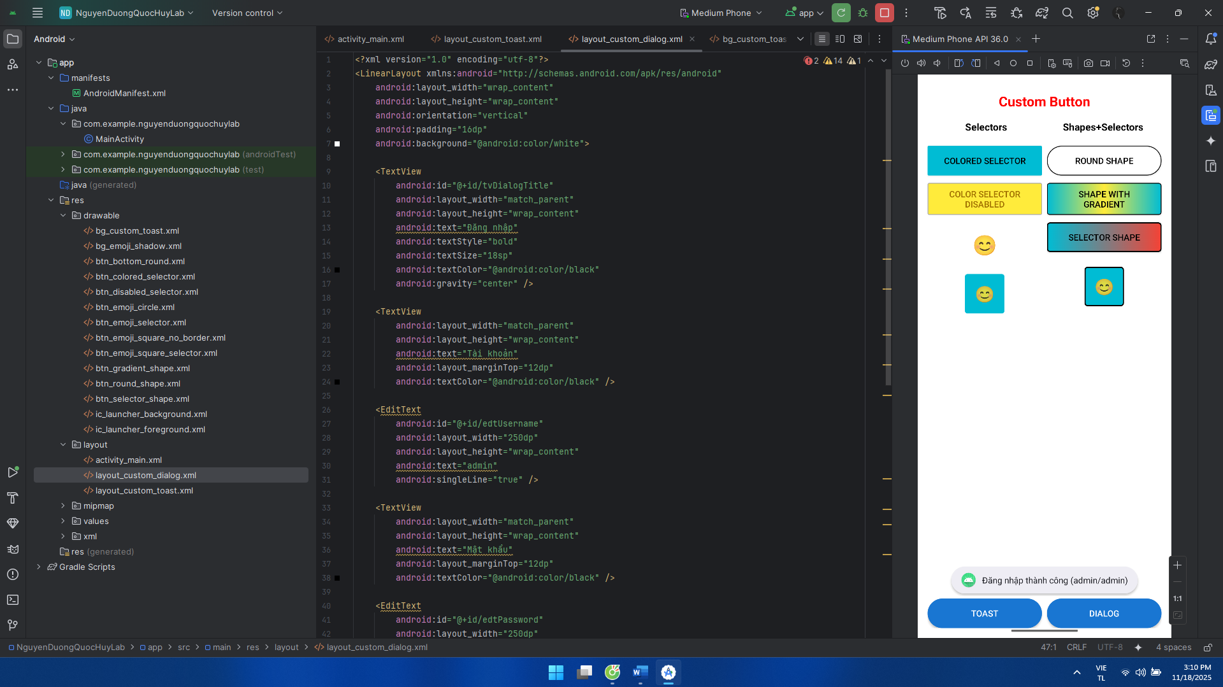

**BÀI TẬP 3: Sử dụng Seekbar, viết chương trình cho phép chọn màu RGB và màu CMY**

**Khai báo manifest:**

<?xml version="1.0" encoding="utf-8"?>  
<manifest xmlns:android="http://schemas.android.com/apk/res/android"  
 package="com.example.nguyenduongquochuylab">

<application  
 android:allowBackup="true"  
 android:icon="@mipmap/ic_launcher"  
 android:label="DrawableExample"  
 android:roundIcon="@mipmap/ic_launcher_round"  
 android:supportsRtl="true"  
 android:theme="@style/Theme.AppCompat.Light.NoActionBar">  
 <activity  
 android:name=".MainActivity"  
 android:exported="true">  
 <intent-filter>  
 <action android:name="android.intent.action.MAIN" />  
 <category android:name="android.intent.category.LAUNCHER" />  
 </intent-filter>  
 </activity>  
 </application>  
</manifest>

**Code trong MainActivity:**

package com.example.nguyenduongquochuylab;  
  
import android.graphics.Color;  
import android.os.Bundle;  
import android.widget.SeekBar;  
import android.widget.TextView;  
import android.view.View;  
  
import androidx.appcompat.app.AppCompatActivity;  
  
public class MainActivity extends AppCompatActivity {  
  
 private SeekBar sbR, sbG, sbB;  
 private TextView tvR, tvG, tvB;  
 private View viewRgb, viewCmy;  
  
 private int r = 0, g = 0, b = 0;  
  
 @Override  
 protected void onCreate(Bundle savedInstanceState) {  
 super.onCreate(savedInstanceState);  
 setContentView(R.layout.*activity_main*);  
  
 if (getSupportActionBar() != null) {  
 getSupportActionBar().setTitle("ChooseColor");  
 }  
  
 sbR = findViewById(R.id.*sbR*);  
 sbG = findViewById(R.id.*sbG*);  
 sbB = findViewById(R.id.*sbB*);  
  
 tvR = findViewById(R.id.*tvR*);  
 tvG = findViewById(R.id.*tvG*);  
 tvB = findViewById(R.id.*tvB*);  
  
 viewRgb = findViewById(R.id.*viewRgb*);  
 viewCmy = findViewById(R.id.*viewCmy*);  
  
 setupSeekBar(sbR, tvR, "R", 255, 26);  
 setupSeekBar(sbG, tvG, "G", 255, 116);  
 setupSeekBar(sbB, tvB, "B", 0, 0);  
  
 updateColors();  
 }  
  
 private void setupSeekBar(SeekBar seekBar, TextView label, String prefix,  
 int max, int startValue) {  
 seekBar.setMax(255);  
 seekBar.setProgress(startValue);  
 label.setText(prefix + " = " + startValue);  
  
 seekBar.setOnSeekBarChangeListener(new SeekBar.OnSeekBarChangeListener() {  
 @Override  
 public void onProgressChanged(SeekBar sb, int progress, boolean fromUser) {  
 label.setText(prefix + " = " + progress);  
 switch (prefix) {  
 case "R":  
 r = progress;  
 break;  
 case "G":  
 g = progress;  
 break;  
 case "B":  
 b = progress;  
 break;  
 }  
 updateColors();  
 }  
  
 @Override  
 public void onStartTrackingTouch(SeekBar seekBar) { }  
  
 @Override  
 public void onStopTrackingTouch(SeekBar seekBar) { }  
 });  
 }  
  
 private void updateColors() {  
 int rgbColor = Color.*rgb*(r, g, b);  
 int c = 255 - r;  
 int m = 255 - g;  
 int y = 255 - b;  
 int cmyColor = Color.*rgb*(c, m, y);  
  
 viewRgb.setBackgroundColor(rgbColor);  
 viewCmy.setBackgroundColor(cmyColor);  
 }  
}

**Trong drawable, custom theo ý muốn:**

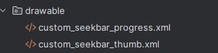

**Code layout:**

<?xml version="1.0" encoding="utf-8"?>  
<LinearLayout xmlns:android="http://schemas.android.com/apk/res/android"  
 android:orientation="vertical"  
 android:layout_width="match_parent"  
 android:layout_height="match_parent"  
 android:background="@android:color/white">  
  
 <LinearLayout  
 android:layout_width="match_parent"  
 android:layout_height="0dp"  
 android:layout_weight="1"  
 android:orientation="vertical"  
 android:padding="16dp">  
  
 <LinearLayout  
 android:layout_width="match_parent"  
 android:layout_height="wrap_content"  
 android:orientation="horizontal"  
 android:gravity="center_vertical">  
  
 <TextView  
 android:id="@+id/tvR"  
 android:layout_width="wrap_content"  
 android:layout_height="wrap_content"  
 android:text="R = 0"  
 android:textColor="@android:color/holo_red_dark"  
 android:textSize="14sp"  
 android:layout_marginEnd="12dp" />  
  
 <SeekBar  
 android:id="@+id/sbR"  
 android:layout_width="0dp"  
 android:layout_height="wrap_content"  
 android:layout_weight="1"  
 android:progressDrawable="@drawable/custom_seekbar_progress"  
 android:thumb="@drawable/custom_seekbar_thumb" />  
 </LinearLayout>  
  
 <LinearLayout  
 android:layout_width="match_parent"  
 android:layout_height="wrap_content"  
 android:orientation="horizontal"  
 android:gravity="center_vertical"  
 android:layout_marginTop="16dp">  
  
 <TextView  
 android:id="@+id/tvG"  
 android:layout_width="wrap_content"  
 android:layout_height="wrap_content"  
 android:text="G = 0"  
 android:textColor="@android:color/holo_green_dark"  
 android:textSize="14sp"  
 android:layout_marginEnd="12dp" />  
  
 <SeekBar  
 android:id="@+id/sbG"  
 android:layout_width="0dp"  
 android:layout_height="wrap_content"  
 android:layout_weight="1"  
 android:progressDrawable="@drawable/custom_seekbar_progress"  
 android:thumb="@drawable/custom_seekbar_thumb" />  
 </LinearLayout>  
  
 <LinearLayout  
 android:layout_width="match_parent"  
 android:layout_height="wrap_content"  
 android:orientation="horizontal"  
 android:gravity="center_vertical"  
 android:layout_marginTop="16dp">  
  
 <TextView  
 android:id="@+id/tvB"  
 android:layout_width="wrap_content"  
 android:layout_height="wrap_content"  
 android:text="B = 0"  
 android:textColor="@android:color/holo_blue_dark"  
 android:textSize="14sp"  
 android:layout_marginEnd="12dp" />  
  
 <SeekBar  
 android:id="@+id/sbB"  
 android:layout_width="0dp"  
 android:layout_height="wrap_content"  
 android:layout_weight="1"  
 android:progressDrawable="@drawable/custom_seekbar_progress"  
 android:thumb="@drawable/custom_seekbar_thumb" />  
 </LinearLayout>  
  
 </LinearLayout>  
  
 <LinearLayout  
 android:layout_width="match_parent"  
 android:layout_height="120dp"  
 android:orientation="horizontal">  
  
 <LinearLayout  
 android:layout_width="0dp"  
 android:layout_height="match_parent"  
 android:layout_weight="1"  
 android:orientation="vertical">  
  
 <View  
 android:id="@+id/viewRgb"  
 android:layout_width="match_parent"  
 android:layout_height="0dp"  
 android:layout_weight="1"  
 android:background="#00FF00" />  
  
 <TextView  
 android:layout_width="match_parent"  
 android:layout_height="wrap_content"  
 android:text="RGB"  
 android:gravity="center"  
 android:textStyle="bold"  
 android:textColor="@android:color/black"  
 android:padding="4dp" />  
 </LinearLayout>  
  
 <LinearLayout  
 android:layout_width="0dp"  
 android:layout_height="match_parent"  
 android:layout_weight="1"  
 android:orientation="vertical">  
 <View  
 android:id="@+id/viewCmy"  
 android:layout_width="match_parent"  
 android:layout_height="0dp"  
 android:layout_weight="1"  
 android:background="#FF00FF" />  
 <TextView  
 android:layout_width="match_parent"  
 android:layout_height="wrap_content"  
 android:text="CMY"  
 android:gravity="center"  
 android:textStyle="bold"  
 android:textColor="@android:color/black"  
 android:padding="4dp" />  
 </LinearLayout>  
 </LinearLayout>  
</LinearLayout>

**Giao diện:**

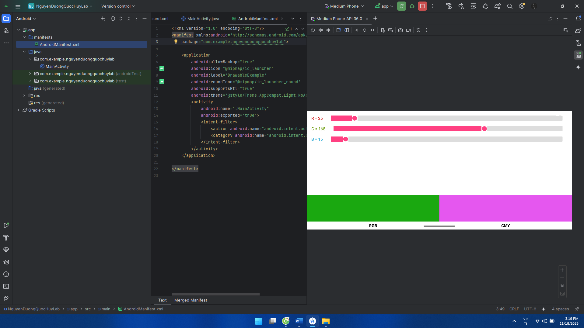

**LAB 8**

**LUYỆN TẬP 1: listview**

**Khai báo ở Manifest**

<?xml version="1.0" encoding="utf-8"?>  
<manifest xmlns:android="http://schemas.android.com/apk/res/android"  
 package="com.example.nguyenduongquochuylab">  
  
 <application  
 android:allowBackup="true"  
 android:icon="@mipmap/ic_launcher"  
 android:label="DrawableExample"  
 android:roundIcon="@mipmap/ic_launcher_round"  
 android:supportsRtl="true"  
 android:theme="@style/Theme.AppCompat.Light.NoActionBar">  
 <activity  
 android:name=".MainActivity"  
 android:exported="true">  
 <intent-filter>  
 <action android:name="android.intent.action.MAIN" />  
 <category android:name="android.intent.category.LAUNCHER" />  
 </intent-filter>  
 </activity>  
 </application>  
  
</manifest>

**Ở file MainActivity:**

package com.example.nguyenduongquochuylab;  
  
import android.os.Bundle;  
import android.view.View;  
import android.widget.AdapterView;  
import android.widget.ListView;  
import android.widget.TextView;  
  
import androidx.appcompat.app.AppCompatActivity;  
  
public class MainActivity extends AppCompatActivity {  
  
 private ListView lvOs;  
 private TextView tvSelection;  
  
 @Override  
 protected void onCreate(Bundle savedInstanceState) {  
 super.onCreate(savedInstanceState);  
 setContentView(R.layout.*activity_main*);  
  
 if (getSupportActionBar() != null) {  
 getSupportActionBar().setTitle("Lab 7");  
 }  
  
 lvOs = findViewById(R.id.*lvOs*);  
 tvSelection = findViewById(R.id.*tvSelection*);  
  
 OsItem[] data = new OsItem[] {  
 new OsItem("Android",  
 "Đây là hệ điều hành Android",  
 R.drawable.*ic_android_os*),  
 new OsItem("iOS",  
 "Đây là hệ điều hành iOS",  
 R.drawable.*ic_ios_os*),  
 new OsItem("Window Phone",  
 "Đây là hệ điều hành Window Phone",  
 R.drawable.*ic_windows_os*)  
 };  
  
 OsAdapter adapter = new OsAdapter(this, data);  
 lvOs.setAdapter(adapter);  
  
 lvOs.setOnItemClickListener(new AdapterView.OnItemClickListener() {  
 @Override  
 public void onItemClick(AdapterView<?> parent, View view, int position, long id) {  
 OsItem item = (OsItem) parent.getItemAtPosition(position);  
 tvSelection.setText("Bạn chọn: " + item.getName());  
 }  
 });  
 }  
}

**OsAdapter:**

package com.example.nguyenduongquochuylab;  
  
import android.content.Context;  
import android.view.LayoutInflater;  
import android.view.View;  
import android.view.ViewGroup;  
import android.widget.ArrayAdapter;  
import android.widget.ImageView;  
import android.widget.TextView;  
  
import androidx.annotation.NonNull;  
import androidx.annotation.Nullable;  
  
public class OsAdapter extends ArrayAdapter<OsItem> {  
  
 private final LayoutInflater inflater;  
  
 public OsAdapter(@NonNull Context context, @NonNull OsItem[] data) {  
 super(context, 0, data);  
 inflater = LayoutInflater.*from*(context);  
 }  
  
 @NonNull  
 @Override  
 public View getView(int position, @Nullable View convertView,  
 @NonNull ViewGroup parent) {  
 ViewHolder holder;  
  
 if (convertView == null) {  
 convertView = inflater.inflate(R.layout.*item_os*, parent, false);  
 holder = new ViewHolder();  
 holder.imgIcon = convertView.findViewById(R.id.*imgIcon*);  
 holder.tvName = convertView.findViewById(R.id.*tvName*);  
 holder.tvDesc = convertView.findViewById(R.id.*tvDesc*);  
 convertView.setTag(holder);  
 } else {  
 holder = (ViewHolder) convertView.getTag();  
 }  
  
 OsItem item = getItem(position);  
 if (item != null) {  
 holder.imgIcon.setImageResource(item.getIconResId());  
 holder.tvName.setText(item.getName());  
 holder.tvDesc.setText(item.getDescription());  
 }  
  
 return convertView;  
 }  
  
 static class ViewHolder {  
 ImageView imgIcon;  
 TextView tvName;  
 TextView tvDesc;  
 }  
}

**OsItem:**

package com.example.nguyenduongquochuylab;  
  
public class OsItem {  
 private String name;  
 private String description;  
 private int iconResId;  
  
 public OsItem(String name, String description, int iconResId) {  
 this.name = name;  
 this.description = description;  
 this.iconResId = iconResId;  
 }  
  
 public String getName() {  
 return name;  
 }  
  
 public String getDescription() {  
 return description;  
 }  
  
 public int getIconResId() {  
 return iconResId;  
 }  
}

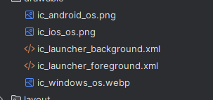**Lưu hình ảnh trong drawable:**

**Giao diện layout:**

**activity_main:**

<?xml version="1.0" encoding="utf-8"?>  
<LinearLayout xmlns:android="http://schemas.android.com/apk/res/android"  
 android:orientation="vertical"  
 android:layout_width="match_parent"  
 android:layout_height="match_parent">  
  
 <ListView  
 android:id="@+id/lvOs"  
 android:layout_width="match_parent"  
 android:layout_height="0dp"  
 android:layout_weight="1"  
 android:divider="@android:color/darker_gray"  
 android:dividerHeight="0.5dp" />  
  
 <TextView  
 android:id="@+id/tvSelection"  
 android:layout_width="match_parent"  
 android:layout_height="wrap_content"  
 android:text="Bạn chọn: "  
 android:textSize="14sp"  
 android:padding="12dp"  
 android:textColor="@android:color/black"  
 android:gravity="center"  
 android:textAlignment="center" />  
  
</LinearLayout>

**item_os:**

<?xml version="1.0" encoding="utf-8"?>  
<LinearLayout xmlns:android="http://schemas.android.com/apk/res/android"  
 android:layout_width="match_parent"  
 android:layout_height="72dp"  
 android:orientation="horizontal"  
 android:padding="8dp">  
  
 <ImageView  
 android:id="@+id/imgIcon"  
 android:layout_width="40dp"  
 android:layout_height="40dp"  
 android:layout_gravity="center_vertical"  
 android:src="@drawable/ic_android_os" />  
  
 <LinearLayout  
 android:layout_width="0dp"  
 android:layout_height="match_parent"  
 android:layout_weight="1"  
 android:orientation="vertical"  
 android:paddingStart="8dp"  
 android:gravity="center_vertical">  
  
 <TextView  
 android:id="@+id/tvName"  
 android:layout_width="match_parent"  
 android:layout_height="wrap_content"  
 android:text="Android"  
 android:textStyle="bold"  
 android:textSize="16sp"  
 android:textColor="@android:color/black" />  
  
 <TextView  
 android:id="@+id/tvDesc"  
 android:layout_width="match_parent"  
 android:layout_height="wrap_content"  
 android:text="Đây là hệ điều hành Android"  
 android:textSize="13sp"  
 android:textColor="#666666" />  
 </LinearLayout>  
  
</LinearLayout>

**Giao diện:**

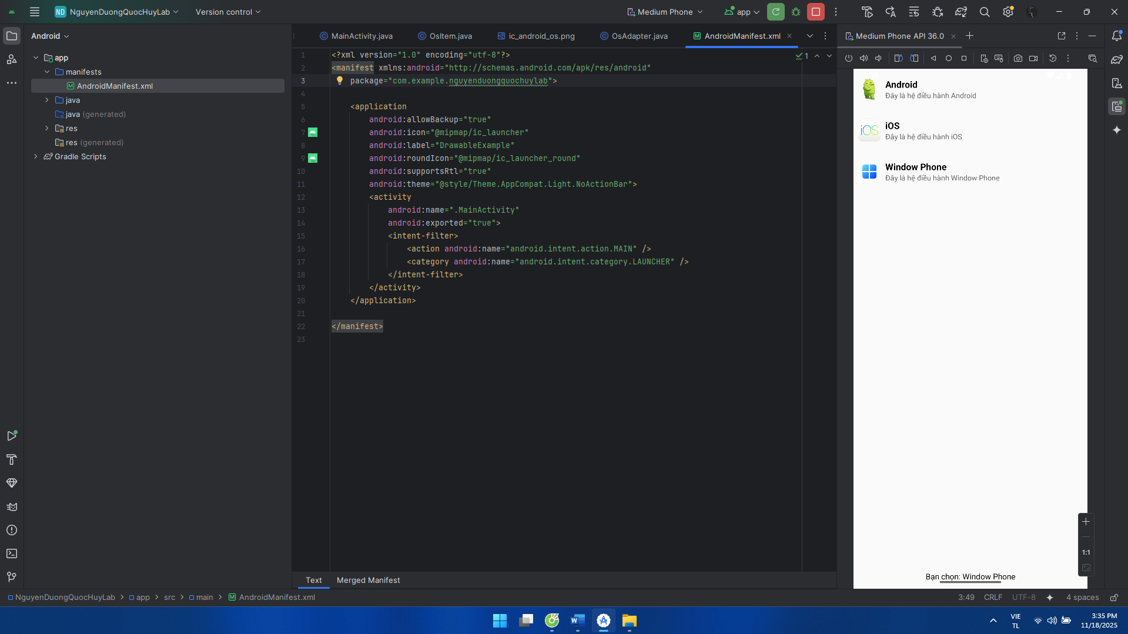

**LUYỆN TẬP 2: Gridview**

**Khai báo trong manifest:**

<?xml version="1.0" encoding="utf-8"?>  
<manifest xmlns:android="http://schemas.android.com/apk/res/android"  
 package="com.example.nguyenduongquochuylab">  
  
 <application  
 android:allowBackup="true"  
 android:icon="@mipmap/ic_launcher"  
 android:label="DrawableExample"  
 android:roundIcon="@mipmap/ic_launcher_round"  
 android:supportsRtl="true"  
 android:theme="@style/Theme.AppCompat.Light.NoActionBar">  
 <activity  
 android:name=".MainActivity"  
 android:exported="true">  
 <intent-filter>  
 <action android:name="android.intent.action.MAIN" />  
 <category android:name="android.intent.category.LAUNCHER" />  
 </intent-filter>  
 </activity>  
 </application>  
  
</manifest>

**Code trong Country:**

package com.example.nguyenduongquochuylab;  
  
public class Country {  
 private String name;  
 private String population;  
 private int flagResId;  
  
 public Country(String name, String population, int flagResId) {  
 this.name = name;  
 this.population = population;  
 this.flagResId = flagResId;  
 }  
  
 public String getName() {  
 return name;  
 }  
  
 public String getPopulation() {  
 return population;  
 }  
  
 public int getFlagResId() {  
 return flagResId;  
 }  
}

**Code trong CountryAdapter:**

package com.example.nguyenduongquochuylab;  
  
import android.content.Context;  
import android.view.LayoutInflater;  
import android.view.View;  
import android.view.ViewGroup;  
import android.widget.BaseAdapter;  
import android.widget.ImageView;  
import android.widget.TextView;  
  
import java.util.List;  
  
public class CountryAdapter extends BaseAdapter {  
  
 private final Context context;  
 private final List<Country> data;  
 private final LayoutInflater inflater;  
  
 public CountryAdapter(Context context, List<Country> data) {  
 this.context = context;  
 this.data = data;  
 this.inflater = LayoutInflater.*from*(context);  
 }  
  
 @Override  
 public int getCount() {  
 return data.size();  
 }  
  
 @Override  
 public Object getItem(int position) {  
 return data.get(position);  
 }  
  
 @Override  
 public long getItemId(int position) {  
 return position;  
 }  
  
 @Override  
 public View getView(int position, View convertView, ViewGroup parent) {  
 ViewHolder h;  
  
 if (convertView == null) {  
 convertView = inflater.inflate(R.layout.*item_country*, parent, false);  
 h = new ViewHolder();  
 h.imgFlag = convertView.findViewById(R.id.*imgFlag*);  
 h.tvName = convertView.findViewById(R.id.*tvName*);  
 h.tvPopulation = convertView.findViewById(R.id.*tvPopulation*);  
 convertView.setTag(h);  
 } else {  
 h = (ViewHolder) convertView.getTag();  
 }  
  
 Country c = data.get(position);  
 h.imgFlag.setImageResource(c.getFlagResId());  
 h.tvName.setText(c.getName());  
 h.tvPopulation.setText(c.getPopulation());  
  
 return convertView;  
 }  
  
 static class ViewHolder {  
 ImageView imgFlag;  
 TextView tvName;  
 TextView tvPopulation;  
 }  
}

**Code trong MainActivity:**

package com.example.nguyenduongquochuylab;  
  
import android.content.Context;  
import android.view.LayoutInflater;  
import android.view.View;  
import android.view.ViewGroup;  
import android.widget.BaseAdapter;  
import android.widget.ImageView;  
import android.widget.TextView;  
  
import java.util.List;  
  
public class CountryAdapter extends BaseAdapter {  
  
 private final Context context;  
 private final List<Country> data;  
 private final LayoutInflater inflater;  
  
 public CountryAdapter(Context context, List<Country> data) {  
 this.context = context;  
 this.data = data;  
 this.inflater = LayoutInflater.*from*(context);  
 }  
  
 @Override  
 public int getCount() {  
 return data.size();  
 }  
  
 @Override  
 public Object getItem(int position) {  
 return data.get(position);  
 }  
  
 @Override  
 public long getItemId(int position) {  
 return position;  
 }  
  
 @Override  
 public View getView(int position, View convertView, ViewGroup parent) {  
 ViewHolder h;  
  
 if (convertView == null) {  
 convertView = inflater.inflate(R.layout.*item_country*, parent, false);  
 h = new ViewHolder();  
 h.imgFlag = convertView.findViewById(R.id.*imgFlag*);  
 h.tvName = convertView.findViewById(R.id.*tvName*);  
 h.tvPopulation = convertView.findViewById(R.id.*tvPopulation*);  
 convertView.setTag(h);  
 } else {  
 h = (ViewHolder) convertView.getTag();  
 }  
  
 Country c = data.get(position);  
 h.imgFlag.setImageResource(c.getFlagResId());  
 h.tvName.setText(c.getName());  
 h.tvPopulation.setText(c.getPopulation());  
  
 return convertView;  
 }  
  
 static class ViewHolder {  
 ImageView imgFlag;  
 TextView tvName;  
 TextView tvPopulation;  
 }  
}

**Để cờ trong drawable:**

**Trong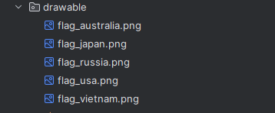 layout:**

**activity_main:**

<?xml version="1.0" encoding="utf-8"?>  
<LinearLayout xmlns:android="http://schemas.android.com/apk/res/android"  
 android:layout_width="match_parent"  
 android:layout_height="match_parent"  
 android:orientation="vertical"  
 android:padding="8dp">  
  
 <GridView  
 android:id="@+id/gvCountry"  
 android:layout_width="match_parent"  
 android:layout_height="match_parent"  
 android:numColumns="2"  
 android:verticalSpacing="8dp"  
 android:horizontalSpacing="8dp"  
 android:gravity="center"  
 android:stretchMode="columnWidth" />  
  
</LinearLayout>

**item_country:**

<?xml version="1.0" encoding="utf-8"?>  
<LinearLayout xmlns:android="http://schemas.android.com/apk/res/android"  
 android:layout_width="140dp"  
 android:layout_height="wrap_content"  
 android:orientation="horizontal"  
 android:padding="6dp"  
 android:background="#FFFFFF"  
 android:elevation="2dp">  
  
 <ImageView  
 android:id="@+id/imgFlag"  
 android:layout_width="48dp"  
 android:layout_height="32dp"  
 android:scaleType="centerCrop"  
 android:src="@drawable/flag_vietnam" />  
  
 <LinearLayout  
 android:layout_width="0dp"  
 android:layout_height="match_parent"  
 android:layout_weight="1"  
 android:orientation="vertical"  
 android:paddingStart="6dp"  
 android:gravity="center_vertical">  
  
 <TextView  
 android:id="@+id/tvName"  
 android:layout_width="match_parent"  
 android:layout_height="wrap_content"  
 android:text="Vietnam"  
 android:textStyle="bold"  
 android:textSize="14sp"  
 android:textColor="@android:color/black" />  
  
 <TextView  
 android:id="@+id/tvPopulation"  
 android:layout_width="match_parent"  
 android:layout_height="wrap_content"  
 android:text="98000000"  
 android:textSize="12sp"  
 android:textColor="#666666" />  
 </LinearLayout>  
  
</LinearLayout>

**Giao diện:**

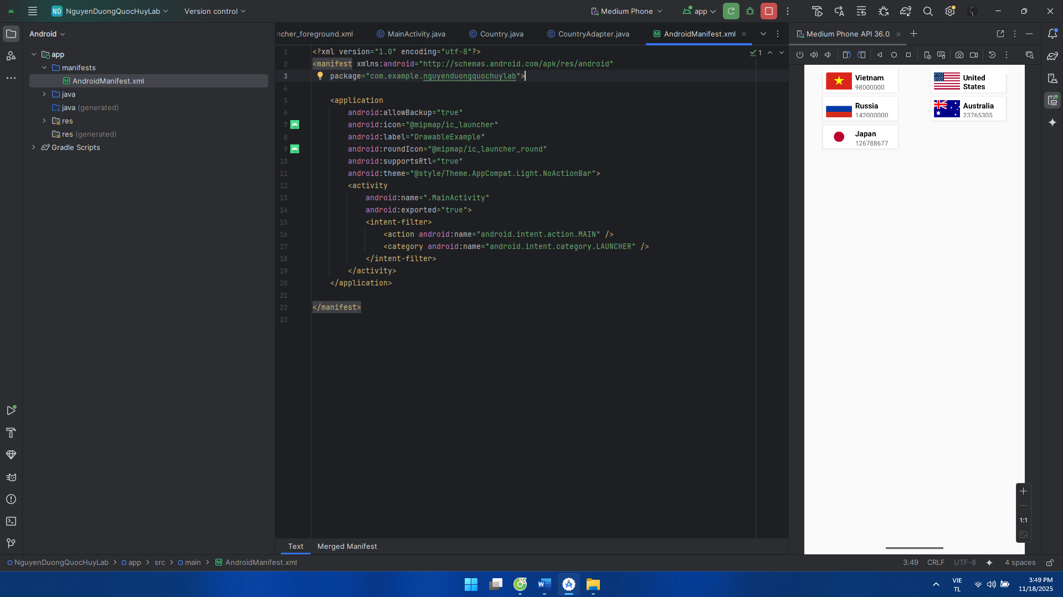

**BÀI TẬP 1: Sử dụng Custom Listview, xây dựng chương trình hiển thị và quản lý các món ǎn như sau**

**Khai báo manifest:**

<?xml version="1.0" encoding="utf-8"?>  
<manifest xmlns:android="http://schemas.android.com/apk/res/android"  
 package="com.example.nguyenduongquochuylab">  
  
 <application  
 android:allowBackup="true"  
 android:icon="@mipmap/ic_launcher"  
 android:label="DrawableExample"  
 android:roundIcon="@mipmap/ic_launcher_round"  
 android:supportsRtl="true"  
 android:theme="@style/Theme.AppCompat.Light.NoActionBar">  
 <activity  
 android:name=".MainActivity"  
 android:exported="true">  
 <intent-filter>  
 <action android:name="android.intent.action.MAIN" />  
 <category android:name="android.intent.category.LAUNCHER" />  
 </intent-filter>  
 </activity>  
 </application>  
  
</manifest>

**Code trong MainActivity:**

package com.example.nguyenduongquochuylab;  
  
import android.os.Bundle;  
import android.view.LayoutInflater;  
import android.view.Menu;  
import android.view.MenuInflater;  
import android.view.MenuItem;  
import android.view.View;  
import android.widget.EditText;  
import android.widget.ListView;  
import android.widget.Toast;  
  
import androidx.appcompat.app.AlertDialog;  
import androidx.appcompat.app.AppCompatActivity;  
import androidx.appcompat.widget.Toolbar;  
  
import java.util.ArrayList;  
import java.util.List;  
  
public class MainActivity extends AppCompatActivity {  
  
 private ListView lvFood;  
 private FoodAdapter adapter;  
 private List<Food> foodList;  
  
 @Override  
 protected void onCreate(Bundle savedInstanceState) {  
 super.onCreate(savedInstanceState);  
 setContentView(R.layout.*activity_main*);  
  
 Toolbar toolbar = findViewById(R.id.*toolbar*);  
 setSupportActionBar(toolbar);  
 if (getSupportActionBar() != null) {  
 getSupportActionBar().setTitle("Đồ ăn nhanh Quốc Huy");  
 }  
  
 lvFood = findViewById(R.id.*lvFood*);  
 foodList = new ArrayList<>();  
  
 foodList.add(new Food(  
 "Hamburger",  
 "Bánh mì kẹp thịt",  
 "Giá: 25.000đ",  
 R.drawable.*img_hamburger*));  
  
 foodList.add(new Food(  
 "Bánh mì",  
 "Bánh mì thịt nguội đặc biệt",  
 "Giá: 12.000đ",  
 R.drawable.*img_banh_mi*));  
  
 foodList.add(new Food(  
 "Bánh bao",  
 "Bánh bao nhân bò, trứng",  
 "Giá: 20.000đ",  
 R.drawable.*img_banh_bao*));  
  
 foodList.add(new Food(  
 "Bánh bột lọc",  
 "Bánh bột lọc nhân tôm, thịt",  
 "Giá: 18.000đ",  
 R.drawable.*img_banh_bot_loc*));  
  
 foodList.add(new Food(  
 "Bánh giò chay",  
 "Bánh giò chay ăn ngon nhẹ",  
 "Giá: 15.000đ",  
 R.drawable.*img_banh_gio_chay*));  
  
 foodList.add(new Food(  
 "Bánh giò nhân thịt",  
 "Bánh giò nhân thịt nóng hổi",  
 "Giá: 18.000đ",  
 R.drawable.*img_banh_gio_thit*));  
  
 adapter = new FoodAdapter(this, foodList,  
 new FoodAdapter.OnFoodActionListener() {  
 @Override  
 public void onEdit(int position) {  
 showFoodDialog(position);  
 }  
  
 @Override  
 public void onDelete(int position) {  
 deleteFood(position);  
 }  
 });  
  
 lvFood.setAdapter(adapter);  
 }  
  
 @Override  
 public boolean onCreateOptionsMenu(Menu menu) {  
 MenuInflater inflater = getMenuInflater();  
 inflater.inflate(R.menu.*menu_food*, menu);  
 return true;  
 }  
  
 @Override  
 public boolean onOptionsItemSelected(MenuItem item) {  
 int id = item.getItemId();  
 if (id == R.id.*action_add*) {  
 showFoodDialog(-1);  
 return true;  
 } else if (id == R.id.*action_exit*) {  
 finish();  
 return true;  
 }  
 return super.onOptionsItemSelected(item);  
 }  
  
 private void showFoodDialog(int position) {  
 AlertDialog.Builder builder = new AlertDialog.Builder(this);  
 builder.setTitle(position == -1 ? "Thêm món" : "Sửa món");  
  
 LayoutInflater inflater = getLayoutInflater();  
 View view = inflater.inflate(R.layout.*dialog_food*, null);  
 builder.setView(view);  
  
 EditText edtName = view.findViewById(R.id.*edtName*);  
 EditText edtDesc = view.findViewById(R.id.*edtDesc*);  
 EditText edtPrice = view.findViewById(R.id.*edtPrice*);  
  
 if (position != -1) {  
 Food f = foodList.get(position);  
 edtName.setText(f.getName());  
 edtDesc.setText(f.getDescription());  
 edtPrice.setText(f.getPrice().replace("Giá: ", ""));  
 }  
  
 builder.setPositiveButton("Lưu", null);  
 builder.setNegativeButton("Hủy", (dialog, which) -> dialog.dismiss());  
  
 AlertDialog dialog = builder.create();  
 dialog.setOnShowListener(dlg -> {  
 dialog.getButton(AlertDialog.*BUTTON_POSITIVE*)  
 .setOnClickListener(v -> {  
 String name = edtName.getText().toString().trim();  
 String desc = edtDesc.getText().toString().trim();  
 String price = edtPrice.getText().toString().trim();  
  
 if (name.isEmpty() || desc.isEmpty() || price.isEmpty()) {  
 Toast.*makeText*(MainActivity.this,  
 "Vui lòng nhập đầy đủ thông tin",  
 Toast.*LENGTH_SHORT*).show();  
 return;  
 }  
  
 String priceText = "Giá: " + price;  
  
 if (position == -1) {  
 foodList.add(new Food(name, desc, priceText,  
 R.drawable.*img_hamburger*));  
 } else {  
 Food f = foodList.get(position);  
 f.setName(name);  
 f.setDescription(desc);  
 f.setPrice(priceText);  
 }  
 adapter.notifyDataSetChanged();  
 dialog.dismiss();  
 });  
 });  
  
 dialog.show();  
 }  
  
 private void deleteFood(int position) {  
 new AlertDialog.Builder(this)  
 .setTitle("Xóa món ăn")  
 .setMessage("Bạn có chắc muốn xóa \"" + foodList.get(position).getName() + "\" không?")  
 .setPositiveButton("Xóa", (dialog, which) -> {  
 foodList.remove(position);  
 adapter.notifyDataSetChanged();  
 })  
 .setNegativeButton("Hủy", null)  
 .show();  
 }  
}

**Code trong FoodAdapter:**

package com.example.nguyenduongquochuylab;  
  
import android.content.Context;  
import android.view.LayoutInflater;  
import android.view.View;  
import android.view.ViewGroup;  
import android.widget.BaseAdapter;  
import android.widget.ImageButton;  
import android.widget.ImageView;  
import android.widget.TextView;  
  
import java.util.List;  
  
public class FoodAdapter extends BaseAdapter {  
  
 public interface OnFoodActionListener {  
 void onEdit(int position);  
 void onDelete(int position);  
 }  
  
 private final Context context;  
 private final List<Food> data;  
 private final LayoutInflater inflater;  
 private final OnFoodActionListener listener;  
  
 public FoodAdapter(Context context, List<Food> data,  
 OnFoodActionListener listener) {  
 this.context = context;  
 this.data = data;  
 this.listener = listener;  
 this.inflater = LayoutInflater.*from*(context);  
 }  
  
 @Override  
 public int getCount() {  
 return data.size();  
 }  
  
 @Override  
 public Object getItem(int position) {  
 return data.get(position);  
 }  
  
 @Override  
 public long getItemId(int position) {  
 return position;  
 }  
  
 @Override  
 public View getView(int position, View convertView, ViewGroup parent) {  
 ViewHolder h;  
 if (convertView == null) {  
 convertView = inflater.inflate(R.layout.*item_food*, parent, false);  
 h = new ViewHolder();  
 h.imgFood = convertView.findViewById(R.id.*imgFood*);  
 h.tvName = convertView.findViewById(R.id.*tvName*);  
 h.tvDesc = convertView.findViewById(R.id.*tvDesc*);  
 h.tvPrice = convertView.findViewById(R.id.*tvPrice*);  
 h.btnEdit = convertView.findViewById(R.id.*btnEdit*);  
 h.btnDelete = convertView.findViewById(R.id.*btnDelete*);  
 convertView.setTag(h);  
 } else {  
 h = (ViewHolder) convertView.getTag();  
 }  
  
 Food f = data.get(position);  
 h.imgFood.setImageResource(f.getImageResId());  
 h.tvName.setText(f.getName());  
 h.tvDesc.setText(f.getDescription());  
 h.tvPrice.setText(f.getPrice());  
  
 int pos = position;  
 h.btnEdit.setOnClickListener(v -> {  
 if (listener != null) listener.onEdit(pos);  
 });  
 h.btnDelete.setOnClickListener(v -> {  
 if (listener != null) listener.onDelete(pos);  
 });  
  
 return convertView;  
 }  
  
 static class ViewHolder {  
 ImageView imgFood;  
 TextView tvName;  
 TextView tvDesc;  
 TextView tvPrice;  
 ImageButton btnEdit;  
 ImageButton btnDelete;  
 }  
}

**Code trong Food:**

package com.example.nguyenduongquochuylab;  
  
public class Food {  
 private String name;  
 private String description;  
 private String price;  
 private int imageResId;  
  
 public Food(String name, String description, String price, int imageResId) {  
 this.name = name;  
 this.description = description;  
 this.price = price;  
 this.imageResId = imageResId;  
 }  
  
 public String getName() {  
 return name;  
 }  
  
 public void setName(String name) {  
 this.name = name;  
 }  
  
 public String getDescription() {  
 return description;  
 }  
  
 public void setDescription(String description) {  
 this.description = description;  
 }  
  
 public String getPrice() {  
 return price;  
 }  
  
 public void setPrice(String price) {  
 this.price = price;  
 }  
  
 public int getImageResId() {  
 return imageResId;  
 }  
  
 public void setImageResId(int imageResId) {  
 this.imageResId = imageResId;  
 }  
}

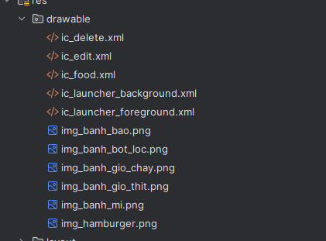**Để xóa, sửa và hình ảnh trong drawable:**

**Trong layout ta có  
activity_main:**

<?xml version="1.0" encoding="utf-8"?>  
<LinearLayout xmlns:android="http://schemas.android.com/apk/res/android"  
 android:layout_width="match_parent"  
 android:layout_height="match_parent"  
 android:orientation="vertical"  
 android:background="#000000">  
  
 <androidx.appcompat.widget.Toolbar  
 android:id="@+id/toolbar"  
 android:layout_width="match_parent"  
 android:layout_height="?attr/actionBarSize"  
 android:background="#3F51B5"  
 android:title="Đồ ăn nhanh Quốc Huy"  
 android:titleTextColor="@android:color/white" />  
  
 <ListView  
 android:id="@+id/lvFood"  
 android:layout_width="match_parent"  
 android:layout_height="0dp"  
 android:layout_weight="1"  
 android:divider="@android:color/transparent"  
 android:dividerHeight="4dp"  
 android:padding="4dp" />  
  
</LinearLayout>

**dialog_food:**

<?xml version="1.0" encoding="utf-8"?>  
<LinearLayout xmlns:android="http://schemas.android.com/apk/res/android"  
 android:layout_width="match_parent"  
 android:layout_height="wrap_content"  
 android:orientation="vertical"  
 android:padding="16dp">  
  
 <EditText  
 android:id="@+id/edtName"  
 android:layout_width="match_parent"  
 android:layout_height="wrap_content"  
 android:hint="Tên món ăn" />  
  
 <EditText  
 android:id="@+id/edtDesc"  
 android:layout_width="match_parent"  
 android:layout_height="wrap_content"  
 android:hint="Mô tả"  
 android:layout_marginTop="8dp" />  
  
 <EditText  
 android:id="@+id/edtPrice"  
 android:layout_width="match_parent"  
 android:layout_height="wrap_content"  
 android:hint="Giá (ví dụ: 25.000đ)"  
 android:layout_marginTop="8dp" />  
  
</LinearLayout>

**item_food:**

<?xml version="1.0" encoding="utf-8"?>  
<LinearLayout xmlns:android="http://schemas.android.com/apk/res/android"  
 android:layout_width="match_parent"  
 android:layout_height="80dp"  
 android:orientation="horizontal"  
 android:background="#111111"  
 android:padding="6dp">  
  
 <ImageView  
 android:id="@+id/imgFood"  
 android:layout_width="64dp"  
 android:layout_height="match_parent"  
 android:scaleType="centerCrop"  
 android:src="@drawable/ic_food" />  
  
 <LinearLayout  
 android:layout_width="0dp"  
 android:layout_height="match_parent"  
 android:layout_weight="1"  
 android:orientation="vertical"  
 android:paddingStart="8dp"  
 android:gravity="center_vertical">  
  
 <TextView  
 android:id="@+id/tvName"  
 android:layout_width="match_parent"  
 android:layout_height="wrap_content"  
 android:text="Hamburger"  
 android:textStyle="bold"  
 android:textColor="@android:color/white"  
 android:textSize="16sp" />  
  
 <TextView  
 android:id="@+id/tvDesc"  
 android:layout_width="match_parent"  
 android:layout_height="wrap_content"  
 android:text="Bánh mì kẹp thịt"  
 android:textColor="#DDDDDD"  
 android:textSize="13sp" />  
  
 <TextView  
 android:id="@+id/tvPrice"  
 android:layout_width="match_parent"  
 android:layout_height="wrap_content"  
 android:text="Giá: 25.000đ"  
 android:textColor="#00FF00"  
 android:textSize="13sp" />  
 </LinearLayout>  
  
 <LinearLayout  
 android:layout_width="40dp"  
 android:layout_height="match_parent"  
 android:orientation="vertical"  
 android:gravity="center_vertical|center_horizontal"  
 android:paddingStart="4dp">  
  
 <ImageButton  
 android:id="@+id/btnEdit"  
 android:layout_width="32dp"  
 android:layout_height="32dp"  
 android:background="@android:color/transparent"  
 android:src="@drawable/ic_edit"  
 android:contentDescription="Sửa" />  
  
 <ImageButton  
 android:id="@+id/btnDelete"  
 android:layout_width="32dp"  
 android:layout_height="32dp"  
 android:background="@android:color/transparent"  
 android:src="@drawable/ic_delete"  
 android:contentDescription="Xóa"  
 android:layout_marginTop="4dp" />  
 </LinearLayout>  
  
</LinearLayout>

**Giao diện:**

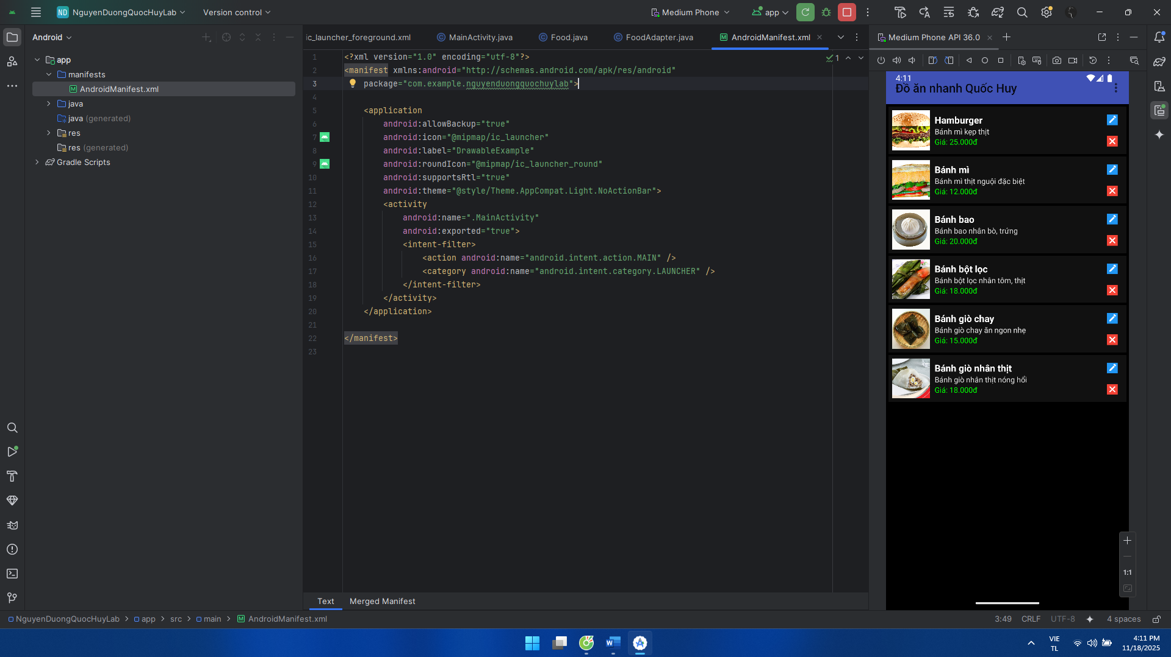

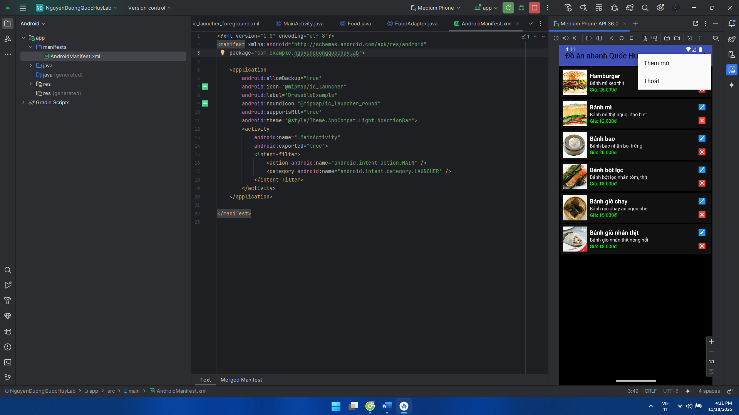

**BÀI TẬP 2: Sử dụng Custom GridView, thiết kế chương trình như sau**

**Khai báo manifest:**

<?xml version="1.0" encoding="utf-8"?>  
<manifest xmlns:android="http://schemas.android.com/apk/res/android"  
 package="com.example.nguyenduongquochuylab">  
  
 <application  
 android:allowBackup="true"  
 android:icon="@mipmap/ic_launcher"  
 android:label="DrawableExample"  
 android:roundIcon="@mipmap/ic_launcher_round"  
 android:supportsRtl="true"  
 android:theme="@style/Theme.AppCompat.Light.NoActionBar">  
 <activity  
 android:name=".MainActivity"  
 android:exported="true">  
 <intent-filter>  
 <action android:name="android.intent.action.MAIN" />  
 <category android:name="android.intent.category.LAUNCHER" />  
 </intent-filter>  
 </activity>  
 </application>  
  
</manifest>

**Code ở MainActivity:**

package com.example.nguyenduongquochuylab;  
  
import android.os.Bundle;  
import android.widget.AdapterView;  
import android.widget.GridView;  
import android.widget.Toast;  
  
import androidx.appcompat.app.AppCompatActivity;  
  
import java.util.ArrayList;  
import java.util.List;  
  
public class MainActivity extends AppCompatActivity {  
  
 private GridView gvContributors;  
  
 @Override  
 protected void onCreate(Bundle savedInstanceState) {  
 super.onCreate(savedInstanceState);  
 setContentView(R.layout.*activity_main*);  
  
 gvContributors = findViewById(R.id.*gvContributors*);  
  
 List<Contributor> list = new ArrayList<>();  
 list.add(new Contributor("Maboo", "283,297"));  
 list.add(new Contributor("SameOldShawn", "252,433"));  
 list.add(new Contributor("Magnitude901", "164,935"));  
 list.add(new Contributor("Brandon", "100,466"));  
 list.add(new Contributor("Clement_RGF", "93,932"));  
 list.add(new Contributor("Nebja", "84,187"));  
 list.add(new Contributor("BBDS", "81,762"));  
 list.add(new Contributor("PleaseDe-ModMe", "79,243"));  
 list.add(new Contributor("DLizzle", "76,331"));  
 list.add(new Contributor("palacelight", "75,497"));  
 list.add(new Contributor("TheDarkKnight", "69,138"));  
 list.add(new Contributor("hellrel", "68,903"));  
  
 ContributorAdapter adapter = new ContributorAdapter(this, list);  
 gvContributors.setAdapter(adapter);  
  
 gvContributors.setOnItemClickListener(new AdapterView.OnItemClickListener() {  
 @Override  
 public void onItemClick(AdapterView<?> parent, android.view.View view, int position, long id) {  
 Contributor c = (Contributor) parent.getItemAtPosition(position);  
 Toast.*makeText*(MainActivity.this,  
 c.getName() + " : " + c.getScore(),  
 Toast.*LENGTH_SHORT*).show();  
 }  
 });  
 }  
}

**Code ở Contributor:**

package com.example.nguyenduongquochuylab;  
  
public class Contributor {  
 private String name;  
 private String score;  
  
 public Contributor(String name, String score) {  
 this.name = name;  
 this.score = score;  
 }  
  
 public String getName() {  
 return name;  
 }  
  
 public String getScore() {  
 return score;  
 }  
}

**Code ở ContributorAdapter:**

package com.example.nguyenduongquochuylab;  
  
import android.content.Context;  
import android.view.LayoutInflater;  
import android.view.View;  
import android.view.ViewGroup;  
import android.widget.BaseAdapter;  
import android.widget.ImageView;  
import android.widget.TextView;  
  
import java.util.List;  
  
public class ContributorAdapter extends BaseAdapter {  
  
 private final Context context;  
 private final List<Contributor> data;  
 private final LayoutInflater inflater;  
  
 public ContributorAdapter(Context context, List<Contributor> data) {  
 this.context = context;  
 this.data = data;  
 this.inflater = LayoutInflater.*from*(context);  
 }  
  
 @Override  
 public int getCount() {  
 return data.size();  
 }  
  
 @Override  
 public Object getItem(int position) {  
 return data.get(position);  
 }  
  
 @Override  
 public long getItemId(int position) {  
 return position;  
 }  
  
 @Override  
 public View getView(int position, View convertView, ViewGroup parent) {  
 ViewHolder h;  
 if (convertView == null) {  
 convertView = inflater.inflate(R.layout.*item_contributor*, parent, false);  
 h = new ViewHolder();  
 h.imgAvatar = convertView.findViewById(R.id.*imgAvatar*);  
 h.tvName = convertView.findViewById(R.id.*tvName*);  
 h.tvScore = convertView.findViewById(R.id.*tvScore*);  
 convertView.setTag(h);  
 } else {  
 h = (ViewHolder) convertView.getTag();  
 }  
  
 Contributor c = data.get(position);  
 h.tvName.setText(c.getName());  
 h.tvScore.setText(c.getScore());  
 h.imgAvatar.setImageResource(R.drawable.*ic_avatar_placeholder*);  
  
 return convertView;  
 }  
  
 static class ViewHolder {  
 ImageView imgAvatar;  
 TextView tvName;  
 TextView tvScore;  
 }  
}

**Tự thêm ảnh nếu muốn vào drawable:**

**Trong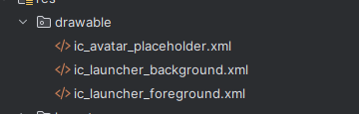 Layout có:**

**activity_main:**

<?xml version="1.0" encoding="utf-8"?>  
<LinearLayout xmlns:android="http://schemas.android.com/apk/res/android"  
 android:layout_width="match_parent"  
 android:layout_height="match_parent"  
 android:orientation="vertical"  
 android:background="#000000">  
  
 <TextView  
 android:id="@+id/tvHeader"  
 android:layout_width="match_parent"  
 android:layout_height="wrap_content"  
 android:text="The Rap Genius Contributors"  
 android:textColor="@android:color/white"  
 android:textStyle="bold"  
 android:textSize="20sp"  
 android:padding="8dp" />  
  
 <GridView  
 android:id="@+id/gvContributors"  
 android:layout_width="match_parent"  
 android:layout_height="match_parent"  
 android:numColumns="3"  
 android:horizontalSpacing="4dp"  
 android:verticalSpacing="4dp"  
 android:stretchMode="columnWidth"  
 android:padding="4dp" />  
  
</LinearLayout>

**item_contributor:**

<?xml version="1.0" encoding="utf-8"?>  
<LinearLayout xmlns:android="http://schemas.android.com/apk/res/android"  
 android:layout_width="match_parent"  
 android:layout_height="72dp"  
 android:orientation="horizontal"  
 android:background="#000000"  
 android:padding="4dp">  
  
 <ImageView  
 android:id="@+id/imgAvatar"  
 android:layout_width="40dp"  
 android:layout_height="40dp"  
 android:layout_gravity="center_vertical"  
 android:scaleType="centerCrop"  
 android:src="@drawable/ic_avatar_placeholder" />  
  
 <LinearLayout  
 android:layout_width="0dp"  
 android:layout_height="match_parent"  
 android:layout_weight="1"  
 android:orientation="vertical"  
 android:paddingStart="6dp"  
 android:gravity="center_vertical">  
  
 <TextView  
 android:id="@+id/tvName"  
 android:layout_width="match_parent"  
 android:layout_height="wrap_content"  
 android:text="Maboo"  
 android:textColor="#BF7FFF"  
 android:textStyle="bold"  
 android:textSize="13sp" />  
  
 <TextView  
 android:id="@+id/tvScore"  
 android:layout_width="match_parent"  
 android:layout_height="wrap_content"  
 android:text="283,297"  
 android:textColor="#FFCC33"  
 android:textSize="12sp" />  
 </LinearLayout>  
  
</LinearLayout>

**Giao diện:**

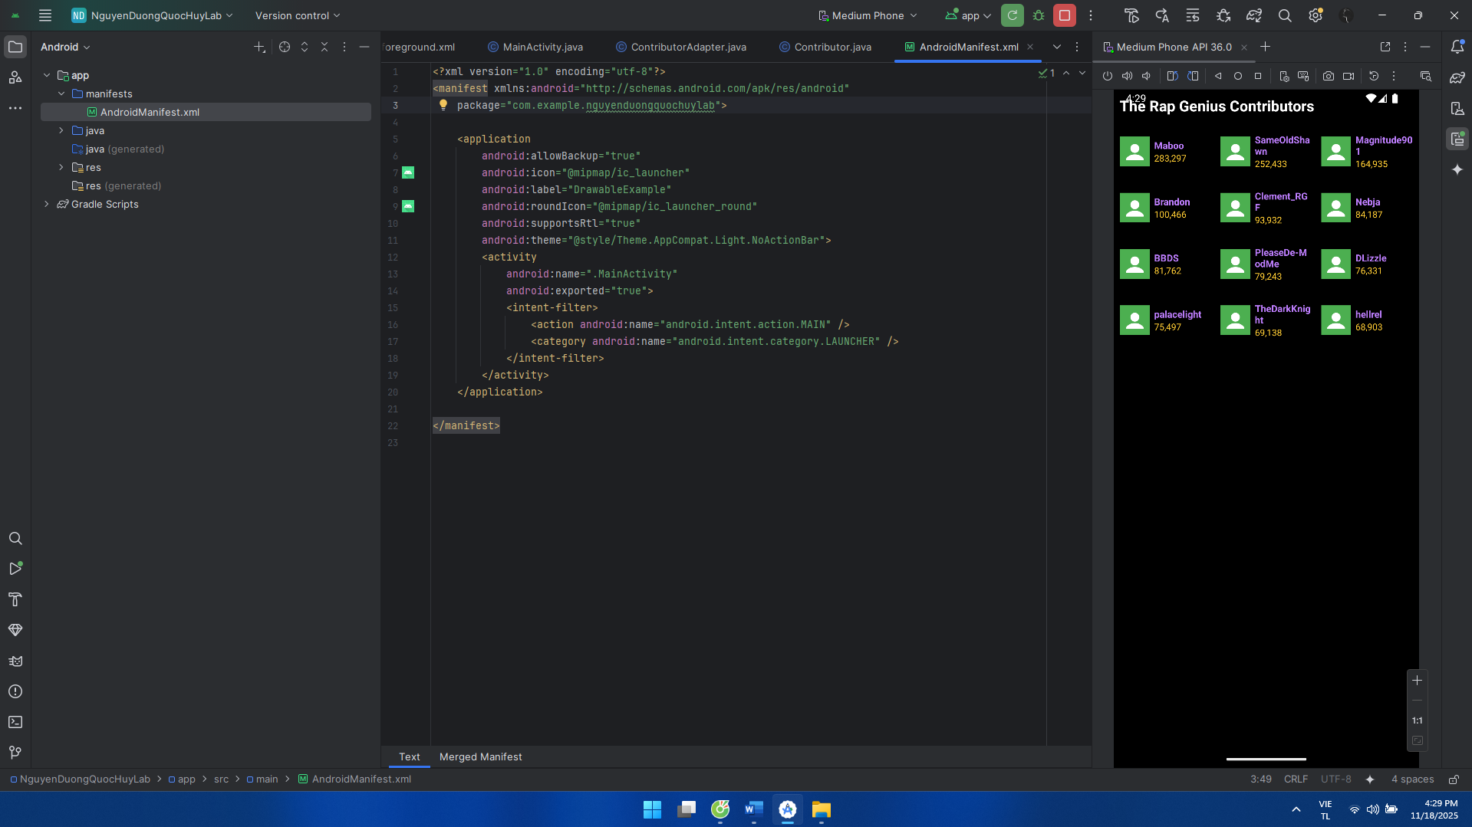

**BÀI TẬP 3: Thực hiện bài tập 1 với các chức nǎng Thêm, xóa, sửa**

**Dựa vào bài tập 1 thay đổi**

**MainActivity:**

package com.example.nguyenduongquochuylab;  
  
import android.os.Bundle;  
import android.view.ContextMenu;  
import android.view.LayoutInflater;  
import android.view.Menu;  
import android.view.MenuInflater;  
import android.view.MenuItem;  
import android.view.View;  
import android.widget.EditText;  
import android.widget.ListView;  
import android.widget.Toast;  
  
import androidx.appcompat.app.AlertDialog;  
import androidx.appcompat.app.AppCompatActivity;  
import androidx.appcompat.widget.Toolbar;  
import android.widget.AdapterView;  
  
import java.util.ArrayList;  
import java.util.List;  
  
public class MainActivity extends AppCompatActivity {  
  
 private ListView lvFood;  
 private FoodAdapter adapter;  
 private List<Food> foodList;  
  
 @Override  
 protected void onCreate(Bundle savedInstanceState) {  
 super.onCreate(savedInstanceState);  
 setContentView(R.layout.*activity_main*);  
  
 // Toolbar  
 Toolbar toolbar = findViewById(R.id.*toolbar*);  
 setSupportActionBar(toolbar);  
 if (getSupportActionBar() != null) {  
 getSupportActionBar().setTitle("Đồ ăn nhanh Quốc Huy");  
 }  
  
 lvFood = findViewById(R.id.*lvFood*);  
 foodList = new ArrayList<>();  
  
 foodList.add(new Food(  
 "Hamburger",  
 "Bánh mì kẹp thịt",  
 "Giá: 25.000đ",  
 R.drawable.*img_hamburger*));  
  
 foodList.add(new Food(  
 "Bánh mì",  
 "Bánh mì thịt nguội đặc biệt",  
 "Giá: 12.000đ",  
 R.drawable.*img_banh_mi*));  
  
 foodList.add(new Food(  
 "Bánh bao",  
 "Bánh bao nhân bò, trứng",  
 "Giá: 20.000đ",  
 R.drawable.*img_banh_bao*));  
  
 foodList.add(new Food(  
 "Bánh bột lọc",  
 "Bánh bột lọc nhân tôm, thịt",  
 "Giá: 18.000đ",  
 R.drawable.*img_banh_bot_loc*));  
  
 foodList.add(new Food(  
 "Bánh giò chay",  
 "Bánh giò chay ăn ngon nhẹ",  
 "Giá: 15.000đ",  
 R.drawable.*img_banh_gio_chay*));  
  
 foodList.add(new Food(  
 "Bánh giò nhân thịt",  
 "Bánh giò nhân thịt nóng hổi",  
 "Giá: 18.000đ",  
 R.drawable.*img_banh_gio_thit*));  
  
 adapter = new FoodAdapter(this, foodList);  
 lvFood.setAdapter(adapter);  
  
 registerForContextMenu(lvFood);  
  
 lvFood.setOnItemClickListener(new AdapterView.OnItemClickListener() {  
 @Override  
 public void onItemClick(AdapterView<?> parent, View view, int position, long id) {  
 Food f = foodList.get(position);  
 Toast.*makeText*(MainActivity.this,  
 f.getName(), Toast.*LENGTH_SHORT*).show();  
 }  
 });  
 }  
  
 @Override  
 public boolean onCreateOptionsMenu(Menu menu) {  
 MenuInflater inflater = getMenuInflater();  
 inflater.inflate(R.menu.*menu_food*, menu);  
 return true;  
 }  
  
 @Override  
 public boolean onOptionsItemSelected(MenuItem item) {  
 int id = item.getItemId();  
 if (id == R.id.*action_add*) {  
 showFoodDialog(-1);  
 return true;  
 } else if (id == R.id.*action_exit*) {  
 finish();  
 return true;  
 }  
 return super.onOptionsItemSelected(item);  
 }  
  
 @Override  
 public void onCreateContextMenu(ContextMenu menu, View v,  
 ContextMenu.ContextMenuInfo menuInfo) {  
 super.onCreateContextMenu(menu, v, menuInfo);  
 if (v.getId() == R.id.*lvFood*) {  
 MenuInflater inflater = getMenuInflater();  
 inflater.inflate(R.menu.*menu_food_context*, menu);  
 }  
 }  
  
 @Override  
 public boolean onContextItemSelected(MenuItem item) {  
 AdapterView.AdapterContextMenuInfo info =  
 (AdapterView.AdapterContextMenuInfo) item.getMenuInfo();  
 int position = info.position;  
  
 int id = item.getItemId();  
 if (id == R.id.*ctx_edit*) {  
 showFoodDialog(position); // sửa món  
 return true;  
 } else if (id == R.id.*ctx_delete*) {  
 deleteFood(position); // xóa món  
 return true;  
 }  
 return super.onContextItemSelected(item);  
 }  
  
 private void showFoodDialog(int position) {  
 AlertDialog.Builder builder = new AlertDialog.Builder(this);  
 builder.setTitle(position == -1 ? "Thêm món" : "Sửa món");  
  
 LayoutInflater inflater = getLayoutInflater();  
 View view = inflater.inflate(R.layout.*dialog_food*, null);  
 builder.setView(view);  
  
 EditText edtName = view.findViewById(R.id.*edtName*);  
 EditText edtDesc = view.findViewById(R.id.*edtDesc*);  
 EditText edtPrice = view.findViewById(R.id.*edtPrice*);  
  
 if (position != -1) {  
 Food f = foodList.get(position);  
 edtName.setText(f.getName());  
 edtDesc.setText(f.getDescription());  
 edtPrice.setText(f.getPrice().replace("Giá: ", ""));  
 }  
  
 builder.setPositiveButton("Lưu", null);  
 builder.setNegativeButton("Hủy", (dialog, which) -> dialog.dismiss());  
  
 AlertDialog dialog = builder.create();  
 dialog.setOnShowListener(dlg -> {  
 dialog.getButton(AlertDialog.*BUTTON_POSITIVE*)  
 .setOnClickListener(v -> {  
 String name = edtName.getText().toString().trim();  
 String desc = edtDesc.getText().toString().trim();  
 String price = edtPrice.getText().toString().trim();  
  
 if (name.isEmpty() || desc.isEmpty() || price.isEmpty()) {  
 Toast.*makeText*(MainActivity.this,  
 "Vui lòng nhập đầy đủ thông tin",  
 Toast.*LENGTH_SHORT*).show();  
 return;  
 }  
  
 String priceText = "Giá: " + price;  
  
 if (position == -1) {  
 foodList.add(new Food(  
 name, desc, priceText,  
 R.drawable.*img_hamburger*));  
 } else {  
 Food f = foodList.get(position);  
 f.setName(name);  
 f.setDescription(desc);  
 f.setPrice(priceText);  
 }  
  
 adapter.notifyDataSetChanged();  
 dialog.dismiss();  
 });  
 });  
  
 dialog.show();  
 }  
  
 private void deleteFood(int position) {  
 new AlertDialog.Builder(this)  
 .setTitle("Xóa món ăn")  
 .setMessage("Bạn có chắc muốn xóa \"" +  
 foodList.get(position).getName() + "\" không?")  
 .setPositiveButton("Xóa", (dialog, which) -> {  
 foodList.remove(position);  
 adapter.notifyDataSetChanged();  
 })  
 .setNegativeButton("Hủy", null)  
 .show();  
 }  
}

**FoodAdapter:**

package com.example.nguyenduongquochuylab;  
  
import android.content.Context;  
import android.view.LayoutInflater;  
import android.view.View;  
import android.view.ViewGroup;  
import android.widget.BaseAdapter;  
import android.widget.ImageView;  
import android.widget.TextView;  
  
import java.util.List;  
  
public class FoodAdapter extends BaseAdapter {  
  
 private final Context context;  
 private final List<Food> data;  
 private final LayoutInflater inflater;  
  
 public FoodAdapter(Context context, List<Food> data) {  
 this.context = context;  
 this.data = data;  
 this.inflater = LayoutInflater.*from*(context);  
 }  
  
 @Override  
 public int getCount() {  
 return data.size();  
 }  
  
 @Override  
 public Object getItem(int position) {  
 return data.get(position);  
 }  
  
 @Override  
 public long getItemId(int position) {  
 return position;  
 }  
  
 @Override  
 public View getView(int position, View convertView, ViewGroup parent) {  
 ViewHolder h;  
 if (convertView == null) {  
 convertView = inflater.inflate(R.layout.*item_food*, parent, false);  
 h = new ViewHolder();  
 h.imgFood = convertView.findViewById(R.id.*imgFood*);  
 h.tvName = convertView.findViewById(R.id.*tvName*);  
 h.tvDesc = convertView.findViewById(R.id.*tvDesc*);  
 h.tvPrice = convertView.findViewById(R.id.*tvPrice*);  
 convertView.setTag(h);  
 } else {  
 h = (ViewHolder) convertView.getTag();  
 }  
  
 Food f = data.get(position);  
 h.imgFood.setImageResource(f.getImageResId());  
 h.tvName.setText(f.getName());  
 h.tvDesc.setText(f.getDescription());  
 h.tvPrice.setText(f.getPrice());  
  
 return convertView;  
 }  
  
 static class ViewHolder {  
 ImageView imgFood;  
 TextView tvName;  
 TextView tvDesc;  
 TextView tvPrice;  
 }  
}

**Trong layout thay đổi item_food:**

<?xml version="1.0" encoding="utf-8"?>  
<LinearLayout xmlns:android="http://schemas.android.com/apk/res/android"  
 android:layout_width="match_parent"  
 android:layout_height="80dp"  
 android:orientation="horizontal"  
 android:background="#111111"  
 android:padding="6dp">  
  
 <ImageView  
 android:id="@+id/imgFood"  
 android:layout_width="64dp"  
 android:layout_height="match_parent"  
 android:scaleType="centerCrop"  
 android:src="@drawable/img_hamburger" />  
  
 <LinearLayout  
 android:layout_width="0dp"  
 android:layout_height="match_parent"  
 android:layout_weight="1"  
 android:orientation="vertical"  
 android:paddingStart="8dp"  
 android:gravity="center_vertical">  
  
 <TextView  
 android:id="@+id/tvName"  
 android:layout_width="match_parent"  
 android:layout_height="wrap_content"  
 android:text="Hamburger"  
 android:textStyle="bold"  
 android:textColor="@android:color/white"  
 android:textSize="16sp" />  
  
 <TextView  
 android:id="@+id/tvDesc"  
 android:layout_width="match_parent"  
 android:layout_height="wrap_content"  
 android:text="Bánh mì kẹp thịt"  
 android:textColor="#DDDDDD"  
 android:textSize="13sp" />  
  
 <TextView  
 android:id="@+id/tvPrice"  
 android:layout_width="match_parent"  
 android:layout_height="wrap_content"  
 android:text="Giá: 25.000đ"  
 android:textColor="#00FF00"  
 android:textSize="13sp" />  
 </LinearLayout>  
  
</LinearLayout>

**Thêm menu_food_context trong menu đã tạo:**

<?xml version="1.0" encoding="utf-8"?>  
<menu xmlns:android="http://schemas.android.com/apk/res/android">  
 <item  
 android:id="@+id/ctx_edit"  
 android:title="Sửa món" />  
 <item  
 android:id="@+id/ctx_delete"  
 android:title="Xóa món" />  
</menu>

**Giao diện:**

